Home, Sweet Home:
Dispatches from the Manchurian Candidate Factory #43
A Kaleidoscope of Nausea, Horror, and Malarkey

To join list: berg.hawkins@protonmail.com | Site: BergendahlHawkins.com
To donate through PayPal: Berg.as.in.Nuremberg.Hawkins@proton.me
20260406 Home, Sweet Home 43_v04
Κύριε, ἐλέησον. (Lord, have mercy.)

Midway?
- Initially heading the wrong way, it took an act of insubordination verging on mutiny by one of the squadron leaders, Waldron by name, for some to head in what turned out to be the correct direction.
- The planes his squadron flew had been obsolete since 1939.
- There was no fighter escort to be had.
- As was the quaint custom for torpedo planes, they went in low and slow, please.
- A-and the fact that their torpedoes were generally known to be NFG doesn’t seem to have overly troubled them, neither.
- I give you: Torpedo 8 <insert demented cackle>.

« M’étant mêlé d’écrire, j’ai été puni de mon impudence ; Having gotten mixed up in writing, I’ve been punished for my impudence;
Rebelle au modes, j’ai offense la mentalité de mon époque. Unfashionable, I’ve offended the mentality of my era.
Les calomnies accumulées peuvent bien avoir raison de ma carcasse ; The accumulated calumnies could very well do in my carcass.
Tout inutile qu’elle soit, ma voix n’en survivra pas moins dans ces pages. » Useless as it may be, my voice will nevertheless survive in these pages.
Traduction du poème autographe de Lu Xun (1933) (My) Translation of Lu Xun’s autograph poem (1933)

My own opinion (borrowing from Richard Wolin) regarding the stuff I write: “Anecdotally rich but analytically impoverished.” i.e., the view from the trenches Start Date: 06-08-25, email Date: 0?-??-26

Distribution: Book group, Addams [sic] Blvd./Cochran Ave. and Environs, FBI & Justice Dept.(by snail mail), Human Rights Watch, LAPD, Landlord, Others.

Purpose: To Ridicule Few. To Amuse Many. To Inform Startle All. A reminder: because of frequent computer malfunctions, when I notice an egregious “printer’s devil,” I’ll bold it, adding [sic]. That’ll bitch it.

This newsletter is in the public domain, anybody is welcome to republish and reuse, including in translation. Bergendahl/Berg (as in Nuremberg) Hawkins, Los Angeles, West Addams [sic] District, USA, 2026

“That night his father told his story. He spoke calmly and quietly. What he described could only be spoken about quietly; it could never be conveyed by tears or screams.” ― Life and Fate, Grossman

“Goodness had nothing to do with it.” ― Mae West

“Grazie alla selezione che eseguo, questo spazio è libero dai vari provocatori e malintenzionati.” ― Nicolai Lilin, from his YouTube channel

What we have: Opacity at the top, transparency at the bottom. I’d prefer a rebuttable presumption of transparency at the top and a rebuttable presumption of opacity at the bottom. ― Greenwald, paraphrased

“… silence is the ultimate consent.” ― Tim Cook, CEO, Apple, 2017

”Liberal democracy appears to represent, above all, a diffusion of power.” ― Williams, 2006, preface

On this third planet from the sun among the signs of bestiality a clear conscience is number one. ― Wisława Szymborska

« Ne cessons pas de relire [‘]Ombres chinoises,[’] pour constater qu’au siècle du mensonge, parfois la vérité relève la tête et éclate de rire. » ― Jean-François Revel

“The US Government is ‘not-agreement-capable’” (I believe the Russian word for this is: Некультурный ― Unless, of course, I’m mistaken). ― General Russian characterization of my Government

“¡Cálmate, mulata!” (Words I’ve taken to heart) ― Heard on the street (at the so-called Advance Market)

Le maoïsme exerce, d'ailleurs une fascination toute particulière sur un certain type d'âmes cléricales ― celles qui ont des nostalgies totalitaires et qui, regrettant inconsciemment la disparition de l'Inquisition et des zouaves pontificaux, retrouvent dans la Chine maoïste l'incarnation d'un songe moyenâgeux ou la Vérité institutionnalisée dispose a nouveau d'un robuste bras séculier pour imposer le dogme, étouffer l'hérésie et extirper l'immoralité. ― Simon Leys, Essais sur la Chine, p 263.

“Systems are like pancakes, you have to throw away a few before they get any good.” ― Carver Andress Meade

“Your precious notes may get you killed.” ― Irene Hawkins, 1995, Florence, Italy (personal communication)

« Que cet écrivailleur écrive ailleurs. Non, mais !»

I always knew I could become like you; I was once afraid I might.

Never trust a smart Black! I say this without the slightest hesitation (Folks, you heard it here first).

¡Aguantar con humor!

As I’m nothing if not a reasonable man, ever willing to be helpful, a suggestion for my neighbors: In order that, come Ragnarök, y’all gets y’all’s stories straight, I encourage you to keep diaries. Helps immensely.
― Berg “Kampfmuzhik” Hawkins

Ein feste Burg ist unser Gott. ― Bach/Ein feste Burg ist unser Berg./Ein feste Burg ist unser Spott.

That a (Black or considered such) no-talent like me can even be thought worth bothering with by the US Government suggests an unhealthy, maybe even delusional, state of mind among These Princes Who Govern Us™. And so I say: “Bollocks!”

My family’s trajectory, summarized: From formal to informal slavery in three generations.

(0) Some Pressing Questions, i.e., Is yet another burning would come to dance, inane:

- Ellsberg
- Tully
- ellsberg older daughter
- Pablo Riviere
- Ruth Brodie
- Beth Wolfson’s cautions, she gingerly probed, while riding bike at beach

Timeline:
- Xentel
- Ellsberg
- pickup to airport from xentel
- Pablo
- ...
Is there anything to all this? Or am I , once again being delusional? « Après avoir réfléchi ce séjour a Mesita Rd., j’arrive a n’en plus savoir a quel sein me vouer. »

How long has all this been going on? evidence: landlord’s family? 2) father?

(1) Tales of the Schwartzkommando (Credit Pynchon’s Gravity’s Rainbow), where, as so often happens, Life imitates Art:

A new section in which I’ll demonstrate by means of specific examples, the truth of the notion that amateurs use physical violence, whereas professionals exploit existing social tensions. Here I’ll list what I perceive to be Aktionen carried out exclusively by Elements of the Negro Persuasion™. Furthermore, I believe these acts to be State-sponsored. Apologies for the font; it seems everything I write, down to that font, is controversial. A-and, are we having fun yet?, in my case, though , as a confirmed Russophile, I believe I’ve by now earned the sobriquet Уданик Пятилетки (Udarnik Pyatiletkiy, Striker for the Five Year Plan). Little old me become a Stakhanovite. Imagine! Long ago, the label was bestowed on me by fellow schizophrenic, comrade in arms, and fellow-traveller, that apparently not irrepressible gadabout, Elmira Izmailova. I have the actual badge to prove it (see Figure ?), too.

(2) The Ca’canny Family™, that double-barreled bunch of State-sponsored Nudniks™, whose MO and psychology I call passive-aggressive mischief-making:

Whether home, running errands, or out for my walks, I sometimes hear the word “Leave” or ‘Go” softly whispered by people nearby. This even happens with bike riders. I first noticed this unsettling phenomenon with neighbor Gadiel Velasquez’ daughters, the three teenage girls I’ve nicknamed “Three Bland Mice.”

Who? A question first posed, years ago, by the Tiny Terror™, Tyson’s son. Prescient, for I, too, now find myself asking the same thing. As in: just who are the faction(s) backing me? The League of All-around Good Guys™, I hope….

(2) Tales of Tylenol (my evil twin, Tylenol Hawkins, that is) or The Kompromat Korner, for I say:
“Money Kompromat is like muck, not good (for Tylenol) except it be spread”:

I confess to, over the years, having consistently demonstrated a (lamentable, it must be said) pattern of airing out my dirty laundry in public (see Figure ?).

Moi et mes querelles de boustifaille…. <TELL>

(3) Plumbing the Depths, (Pukka) Wanker (No doubt due to the abysmal rate of reproductive success characteristic of we paranoid schizophrenics) that I Am:

About fellow student Arno X, another anecdote. At an apartment I shared with two Caltech students, sitting next to me, he, in an unsolicited remark (approximately accurate ― this was over forty years ago) once said: “… I’m so big, I’d give you hemorrhoids.” Upon such meat has this, our Caesar, fed (Credit Shakespeare, adapted by Friedenberg). Gentle Reader™, the anecdote may suggest that, all in all, Arno X and Caltech were perhaps not a good fit. Mebbe no better a fit than with me, en l’occurrence... Ah, the vagaries of affirmative action. A-and are we having fun yet?

Further (recent) scurrilous incidents or allegations of a sexual nature by:
(1) Tyson the Corn-fed Golem with the On/Off Switch™. (2) The Tiny Terror™, Tyson’s son. (3) Mrs ‘Bell™, a former neighbor. (4) Two Spanish-speaking construction workers, apparently witnesses to an attack by Tyson on the sidewalk, yards from my bungalow. According to Officer Shelburne, they claimed to have seen an altercation between Tyson and me in which the word “pedophile” was used. This after I’d previously asked them, in front of a resident of 2642 S Cochran Ave, whether they’d seen anything – to which they’d replied in the negative.
A list of their accusations:
(1) Many years ago, I can remember the date as I was on the lawn outside, working on a system for Greg William, a solar customer. Tyson used the word “pedophile” as he stood nearby. (2) Last year, in 2025, use of the same word by Tyson’s son to to a security guard at the R-Ranch Market, again within earshot of me. (3) That same day, he also asked a man at a construction site for advice on what to do if someone were bothering him. This as he followed me, occasionally shouting at me. (4) The use of the word “pedophile” by LAPD officer Shelburne when he reported having spoken to the two construction workers mentioned above. (5) A comment by former neighbor Saint Bernard™ in which he, during a police visit occasioned by Mrs ‘Bell™ in which he spoke to the officers, said: “I’ve also heard other things about him.” (6) An allegation made by Tyson to LAPD officer Shelburne(?) that I’d looked at his daughter’s behind. (7) According to Officer Shelburne, Tyson also accused me of writing about his daughter’s breasts. (8) To an LAPD Officer she’d summoned, Mrs ‘Bell™ accused me of being a peeping tom.
Conclusion:
(1) Perhaps Tyson could provide an explanation for his and his son’s use of the word “pedophile” in comments made years apart. (2) As for Mrs ‘Bell™’s ever being in a position to explain her behavior or accusations, I despair… (3) NB: at least one of Tyson’s charges can be definitively be put to rest by searching the 500+ pages I’ve had online for many years. If shown to be false, the fact would cast doubt on anything out of that family. (4) There should be a verbal confrontation involving: (a) The neighbor, witness to statements by (b) Two construction workers. (c) LAPD officer Shelburne. (d) Tyson. (e) Me, on the subject of whether the two saw Tyson attack me and whether I said anything throughout. (5) Are any of these accusations documented in police files? Where’s yr data? (6) A liar is not to be believed even when he speaks the truth.

(4) Les Potins de la Commère (Inspired by Sixties Showbiz Gossip Columnist, Carmen Tessier; an Occasional Look at what I Entertain Myself With):

- From Ozzy Osborne’s Black Sabbath, the album Paranoid, see the song War Pigs.
- A-and now, do send in the Beach Boys, won’t you? By which I mean, of course, the song, Barbara Ann.
- That Gopnik hardbass musical genre; featuring guys scarier-looking even than the Die Antwoord duo.
- The King’s Choice, a Norwegian film about the opening days of WWII in Norway. I’ve watched it twice. Uplifting. To me, King Haakon VII was, along with de Gaulle, the last great European. Honorable mention: Schmidt, Brandt, Monet, McMillan, Mendès-France, Thatcher (not my favorite, though), and Attlee (qui, comme nous autres Américains d’aujourd’hui, n’a pas su prendre son virage, poor fellow). At least Clem’s hands were, mostly, “Ajax”-clean). Though, on account of that very same “Operation Ajax”, I do not include Churchill in my list as, mentioning the pressing sum of forty billion dollars in yearly revenue lost, he pressed the Americans most intently for what is now called “regime change.” The contrast with what’s on offer nowadays in Europe’s political scene is stark. Think Haakon-types vs. what we now seem to have ― almost uniformly ― quislings or worse. Such a shift, and in such a short time, too. Weird. I must end this now; this is enough insult for one day.
- Zamyatin, Lem, Ellul, Lu, Hašek, Dostoevsky, Čapek, Kadaré, Lewis, Kafka, Feffer, Shteyngart, Orwell, Huxley: They all foresaw, announced, noted, deplored; with some even mocking, the 20th Century arrival of “That Hideous Strength.”

(5) To my Landlord, AFJ Investments’ Tiffany Anderson-Ca’canny aka “Our Lady of the Perpetual Inspections™.” One in an Occasional Series:

Incidents best characterized by the catty titles: “A Tempest in a Teapot Chamberpot.” or « l’État et ses Jeux de Passe-passe». Take your pick.
(1) Filed case #SO316129 on 11/5/2025 for required online payment, harassment. (2) Case closed without my being informed. I received notice on 12/15/26. Reason: I failed to reply to the request for additional information. (3) On 1/6/2026, filed case #SO318226 for required online payment, harassment. An attempt to save money by paying rent by check was stymied when the landlord ordered all rent to be paid at the portal. I'm forced to pay this way, incurring extra charges. The problem was fixed after the City ruled in my favor. (4) Another case opened, case #976924, regarding a leaking roof. (5) Case #976924 closed by LAHD without repairs having been made. (6) In reply to questions posed over the phone, Alfredo Balandra of alfredo.balandra@lacity.org was referred to me by an LAHD employee named Joseph (last unknown) in Code Enforcement who called about my complaint. (7) In reply to my email of February 23, Mr Balandra replied on February 25 with questions about the relevant(?) case number (included in my email), the comment that he was the wrong person to ask (he advised I contact the RSO), and that I’m not to attempt to make repairs on my own. (8) A further email, sent on April 7, still resulted in no reply from Mr. Balandra to my question of whether I’m allowed to put a tarp over the leaking roof. (9) At the start of February, I begin paying rent in person, by check. (10) That month, and later, I’m unable to enter the AFJ office and pay rent in person promptly. I'm forced to wait on the sidewalk, outside AFJ Investments, for the secretary or owner to come downstairs to let me in, usually after some time. (11) I find a rent check is not cashed for a month. (12) On the following month's check handover in person, I must wait 2 hours outside the office before the owner drives up. The secretary was possibly there all along, as, after a few messages had been left, the answering machine was turned off. Furthermore, I always send an email on the same day, ahead of my visit, during office hours. (13) On 5/2/26, my attempt to find Saturday office hours was unsuccessful when AFJ Investments did not reply to the email. I went anyway, and found the office to be either closed or the secretary not answering. (14) On the following Monday, my attempt to deliver the check leads to my confusion when Ms Tiffany Anderson, landlord and owner of AFJ Investments, answers the intercom and buzzes me in. Entering, I find the office is closed. The secretary soon appears, and I hand over the May check. (15) March and April checks are eventually cashed simultaneously. (16) On 4-22-26, an inspection by LAHD Inspector Boyd is carried out. (17) Door replacement (previous door damaged by roof leak) is botched by AFJ workers, leaving me unable to close or open the front door properly. (13) No notification of inspector’s findings received by me. (18) During a work visit, an AFJ employee has me move items in the bungalow for him to access the attic for inspection, I comply. (19) No roof repairs are made that I’m aware of. (20) During another visit, an AFJ employee tries to have me sign a document to the effect that repairs had been made, I refuse. (21) As of 5/15/2026, still no roof repairs made. (22) On 4-22-26, a notice of reinspection regarding case #976924 is taped to my bungalow, it is dated March 24, 2026. (23) On May 5, 2026: Reinspection by Boyd, the man who initially found 4 violations. Smoke detectors are still missing (I'd removed them last year when both began going off at random during the night ― as I explained to landlord and Inspector Boyd). (24) During reinspection, landlord Anderson asks if anything else is outstanding. Without answering, I refer her to the City notice taped outside my door. (25) After the visit, Inspector Boyd does not inform me of his findings, not even verbally. He waits on the sidewalk, outside, and confers with the landlord. That afternoon, the landlord's workers replaced the smoke detectors. Present with the handyman, was the AFJ secretary(?) from earlier office visits, in which I waited 2 hours downstairs before I could pay rent. (26) A notice of a General Manager's Hearing is posted on the bungalow across from mine. No letter or call informs me of the subject of the hearing. (27) Not having read the notice before it is removed, I begin to worry. (28) On 5-14-26, I tried to find the reason for this hearing, searching the internet unsuccessfully. (29) On 5-14-26, I tried to file another complaint with LAHD for my leaking roof, but the website or my browser failed during 2 attempts. (30) On 5-14-26, a call to 2 people at the housing department resulted in a return call on the same day. (31) I get what Blanca Contreras, from a City hearing hotline(?), says is a courtesy call. This seems to resolve the issue. But I’m still unable to get a clear idea of the status of my leaking roof complaint. I'm also unable to get a clear idea of the nature of the General Manager Hearing though I do get a hearing date. Ms Contreras is also unsure of the case number, but does give me one. (32) An email from LAHD, received the next day, 5/15/26, confirms the case # she gave (case #948203). (33) Though I was unable to get information on my leaking roof complaint from her. According to her, “the case is possibly too new to be in the system.” A-and are we having fun, yet?
(A Copy of this section being sent to City for inclusion in a General Manager’s Hearing set for May 26, 2026)

(5-18-26) @ 13:39 I invite anyone mentioned in the 33 point account listed on 5/15/26 to discuss them with me if there are disagreements. Preferably by email. (Update 5-22-26): I will not be attending the hearing but have instead asked for a summary of proceedings.

(6-4-26) Having first given email notice of my visit to pay rent today, I only had to wait a half hour on the sidewalk for yr employee to answer the several voice messages I’d left before she let me in. You are to be congratulated on yr (relative) promptness. Ausgezeichnet! Prima!

(6) The Cat Walks (Backward, Natch!):

… and, as she tucked me in gently, I smiled a smile of contentment… Her name was Elmira Izmailova.

- Torrance (?) PC customer - CD drive limit problem fixed ― pic of young girl on desktop ― customer mentions VPN to bypass security? Insurance policy for my would-be masters?
- CA highway patrol letter of item belonging to me found in stolen car in San Gorgonio pass – Don’t want appear chrulish but mui=ust ask, is this Another insurance policy, this time for my masters???

- Woman picks me up as I strolled one noight on Colorado blvd in 1972. - Now, Gentle Reader™ I don’t want you to feel I’m abusing yr credulity. Here. - But a second woman on Colorado Blvd/Colubarado - according to a Greek (Natch!) wag I once knew.

(4-28-26) A decade ago, on one of my visits to Florence, Irene, by then with Alberto Zucconi, her current partner, spoke of a trip they’d made to India. She mentioned a scientist nicknamed “Rocketman,” speaking of him several times. I bring this up after watching a YouTube interview in which mention was made of the latest Indian ballistic missile, the Agni-V, a rocket with a range of 5000 to 8000 kilometers. The guest being interviewed asked rhetorically who the target could possibly be for a missile of that range. The subject had come up during an excursion into the current state of US (ce beau pays d’Apaches) Government diplomacy gangsterism. Vu ?

When I lived on mesita/With Kathy Evans at the beach, German-looking(?) attractive woman walks by on steps/I was to run into Kathy’s husband years later at SM beach. … <EXPAND>

In 1992, while working at Terminal Data, I received a call at work, possibly from my sister. Strangely, it was a a phone I’d never used, in a room with a window looking out onto the manufacturing area. While we talked, a young woman, Korean-American, came into view on the other side of the window. She danced “ back and forth for a few minutes before, finally, returning to her work and disappearing from view. I remember she was pretty, shapely and as my friend, Reuven Levy had previously said, she was a math major, worked in assembly, and did not date Americans.

Some possible parallels with a long ago event which marked me: (1) In the sixties, at dinner, Father, upset at something I’d done, pulled me away from the table, grabbed me by the feet and turned me upside down before shaking me. No one commented, those present affected to not notice. (2) Here, in what I call the Addams [sic] Family neighborhood, a similar situation obtains. The circus here has gone goes on for years, unabated, a-and people, like everyone at that dinner table, do not notice, nor do they comment. I can now refining the simile of my being a bull which carries with it its own china shop. As, nearby, witnesses, mute, hands folded, watch the scene without comment. I see it as a sort of conspiracy of silence, going on now for fifty years. Perhaps, though I cannot be sure, this scene is replicated in the country at large.

(7) Running the Public Transit Gauntlet or “Prendere in Giro”:

Nothing to report…

(8) Daffynitions (i.e., Section 8 stuff) With profuse apologies for the obscurity of it all. Oh, So Sorry™:

“Lakeitel days,” phrase: Contains a portmanteau word combining the word lackey and Keitel, the name of a German WWII general known for his lickspittle ways, thus the moniker. The phrase characterizes so much of Europe’s atmosphere and leadership nowadays. A Europe which, in less than a century, has gone from the frying pan of “Keitel days” to what we can now properly call the fire of “Lakeitel” (or, to be fair, should it be the reverse? – Stay tuned.) Think Mark Rutte’s recent (I write this on April 13, 2026) performance at the White House or, among others, for the field, it is crowded, that of – pronounced in the French manner – “« la Keitel », (presumably to Die Leiden des) Ursula von der Leyen(s).

Δούλος (Doulos), n: Greek word for slave, French slang for informant; also the title of a film, Le Doulos, staring Jean-Paul Belmondo. In a striking example of unintended irony, I once took friend Katsumasa Kozono to see it before his return to the Japans. And so I exclaim: “Shikata ga nai.”

Denkmal, n: German word meaning memorial (with a positive connotation) !خیر (Persian for No!). Not to be confused with the next definition.

Merkmal, n: German word meaning memorial (with a negative connotation). ...

“Bergie’s number,” phrase: Take a person’s level of (state-sponsored) predatory behavior, divide by his/her level of victimhood and you have Bergie’s number. A value which, when applied to the “walking dead” among us, unfortunately generally tends to increase over time. The concept is most fruitful.

“征夷大将軍”(Seii taishōgun, Barbarian-subduing generalissimo), military title: Inspired by de la Rey, a song of SA singer Bok van Blerk; does the title not suggest yet another nickname for yr Intrepid Servant™ (Wink-wink, nudge-nudge)?

Gleichschaltung, n: The German word for synchronization. Of a very dubious original provenance, the word came to be applied (see eerily prescient comments by Dalrymple/Daniels) to the European Union. I’ve since repurposed the shameful thing, so frequent are the “meets cute” around these parts. Usage: “On May 7, 2026, Brother Cantinflas™, in back-to-back Gleichschaltung Aktionen, walked past my bungalow just as I was emerging from my front door.”

Jew, n: Word describing a loosely-defined group (tribes?) known, along with the Heathen Chinee™, for their all-round excellence and, generally speaking, civilized behavior. However, when followed by an exclamation point, an expletive. For an example of the second, see a previous HSH issue in which I recount a telling incident in which a fellow(?) fellow of the Negro Persuasion™ whispers the word as he passes me on the sidewalk. For an example of the first a-and a bit of fun, see below.

Obombino, n: A member of that great and mighty tribe of idjits found to have voted for President Obombo. To qualify for membership in this select tribe, one must have voted for the blighter; both times. Plural: Obombini. Usage: “On the Westside of Los Angeles, especially beyond the 405 freeway, many Obombini are to be found.” I trust you, Gentle Reader™, will let me know when I’ve gone too far? <insert demented cackle>

Hoxhaism, adj: Also known as Hoxhaist Deviationism (according to Tito, a pernicious doctrine). Hoxhaism is not to be confused with hoaxism. No, not hoaxism. I. Said. Hoxhaism. About hoaxism, more below. I’ve endured the antics of various workmen, neighbors, fellow tenants, librarians, LAPD officers, MDs, Los Angeles Housing inspectors, and last but not least, landlord AFJ Investments. Truly, when one considers the implication of these displays of tomfoolery and, even, simultaneously at times, occasional, silent earnest entreaties/fear, is this not, as Tito is reputed to have judged the kind of communism practiced by Hoxha’s People’s Socialist Republic, a republic in the “bashibazouk” style? And so I say to them as are behind these poor souls’ pantomimes: « Espèce de bande de bachi-bouzouk des Carpates … de tonnerre de Brest !» (French for: “This place is an Oh! So Shabby™ train wreck!”) <FIXFIXFIX>

Hoax, n: … <EXPAND> Being subjected to a regime of hoaxes, or to a regime of Hoxhas. Which do you prefer?

Jakarta, n: A proper name, the capital of Indonesia. Also, as told by Allende’s niece, a coded threat. She’s told of graffiti found on walls of Santiago, capital of Chile, in the weeks and months before the coup which toppled her uncle. Also, from my personal experience in this apartment complex, examples of vague threats: (1) Graffiti sprayed on the sidewalk outside our complex: “Eat a d*ck, bergie” (pic available). (2) Words of tenant Corn-fed Golem Tyson™: “Up, Up!” A phrase repeated for months on end as he walked by my bungalow. (3) Several physical attacks (LAPD police report #s available) by Tyson carried out over the years. (4) The “Tiny Terror™’s years-long campaign of petty vandalism, weirdness and intimidation. (5) Landlord Anderson-Ca’canny’s emailed threat: “… The police are on their way...” This emailed after I refused entry to an employee of hers. (6) Mrs ‘Bell shouting at me from behind as I return from an errand, buying a color laser printer: “You’ll pay for this, you dumb ass!” (7) Neighbor Tub-thumper™’s wife, to me: “You’ll have to go in.” usw, usw, usw. Mind, I’m only mentioning the explicit stuff I can point to with confidence. And so I again ask: “Where the f*k I am?” (Said with a pronounced plaasjaapie accent)

Saudade, n: A psychological condition, not restricted to those of a Latin temperament. Best described as what one has left after someone or something held dear has gone forever; for the Portuguese, their Empire, say. For a haunting example of the usual final destination (a quiet backwater of little relevance, perhaps a ghetto or, at the very extreme, Yeltsin’s Russia), listen to the song Malfamé Alfama (itself a ghetto of Lisbon) by the renowned and beautiful Portuguese singer Amalia Rodrigues.

Cattle call, phrase: Meant as a slighting reference to any mentality prepared to indiscriminately audition wholesale numbers of innocents in the hope of finding “talent.” The phrase defines a phenomenon, with end results witnessed by me countless times, in which a random innocent is examined then waylaid, before being inducted into the Fraternity of Morlock™, e.g., a Colette Walczak. A munchkin without discernible political opinions and, what’s more, an upper-middle-class one from deepest, darkest Indiana. If the US Government can victimize one such as she, is anyone safe? The Russians, probably similarly afflicted, though generally more forthright about these things, call it a “meat storm” (Credit the Daily Mail).

Lupanar, n: A word previously unfamiliar to me though it be French. I was introduced to it in the seventies in a Los Angeles Times piece by a writer I’m still trying to identify. For a definition, see “Mesita Rd.” below.

Mesita Rd., place name: A small street, located in Pasadena, ending in a cul-de-sac. I lived there for four years as tenant of an older woman. While remaining within the bounds of propriety, I can still convey the prevailing atmosphere there with an anecdote. The neighbor across the street, owner of Fox’s Five Acres, a car dealership, once thought to comment on my hiking boots which, having seen better days, let my toes be visible through the front which had split open. “They look like a tongue,” he suggested after examining them before checking my countenance. C’était quand même quelqu’un qui avait fait Iwo Jima. Ding hao, monsieur !

Bagnard wear, phrase: It is by a happy coincidence that I can add this term to examples in my daffynition of the color Orange.

Malatropism, n: Yet another delusional affliction. One might give as example the celebrated phrase: „Drang nach Osten“. A condition shared by more than the usual suspect… This (usually) ends in tears. Furthermore, it is to be devoutly hoped that Our Little Red Brothers™ (Credit John Brunner), better (formerly?) known to some as Heathen Chinee™, are not similarly afflicted, else I cannot answer for the future of Western civ. Curiously, the word itself is an example of a malapropism. A-and aren’t I, once again, showing myself a … etc., etc., etc.

Hippopotamus, n: A large animal known to be fond of wallowing in mud; also the title of a play (I once had an epiphany at a performance) by little-known Romanian playwright Vafanculescu (ditto for the epiphany).

(9) The Eccentric Shaft™: Dubious Interactions with my Fellow Crazies. A-and me a Paranoid Schizophrenic, Too (Credit: Irene Hawkins, personal comm.): There’s method to this madness, I daresay. « On fend le bois avec un coin en bois. » (One splits wood with a wedge of wood.)
True in two ways: (a) Mrs. ‘Bell’s mentally ill – or acts it. I’m mentally ill. (b) She’s Black, I’m considered Black (a-and am, for all I know).

After Brother Cantinflas™ intercepted me as I emerged from bungalow, asking that I return some weights “when I was done with them” as, “there are others using them, I: (1) Told him I’d taken three in all. (2) That I’d Return them all. (3) Knowing he has an elaborate set of his own weightlifting equipment on the other side of his bungalow, after returning them to where I’d found them, by the trash containers, I’ve begun taking occasional pics, presumably time stamped.

(6-21-26) Coming back from my walk this noon, Mrs ‘Bell was…. Yet another skit/show.

(10) La Rubrique des Gueules Cassées:

- Irene, meaning well perhaps, recently suggested three books I might look at to combat my hoarding behavior (is it so obvious that she , halfway around the world, could be concerned?). I immediately reserving them at the library, I began wondering if this were not a case of locking the barn door after the horse has fled. Much as when, speaking to a doctor at KP about the possibility of being evaluated for hoarding as I was in the process of transferring most of my stuff to storage, preparatory to getting rid of it. The doctor, immediately prescribed an antipsychotic,. Later, Irene reassured me that this was merely for better sleep. Though one could object that if that was the case, why not prescribe a sleeping pill?. I’ve already commented in the curious attitude among medical and medical-related personnel which, while concerned about my stress level, does not address things like the extreme variability of my blood pressure whenever I visit KP or the veritable circus, near and far, I live in.
- About my scavenging and hoarding mindsets: Like horse and carriage, they go together, do they not?
- My arthritis is worse, especially of my shoulders.
- Occasional excruciating pain, specifically under the fleshy part of my left big toe. It reminds me of an episode of aerodontalgia I suffered from during flights as the plane changed altitude. It causes me to flinch and yelp or groan. Happens at random times with momentary pulses of sharp pain repeated from once to several times per second.
- I find myself sensitive to noises or quick movements. Examples: (1) Nearby engines idling for long periods of time. (2) Loud motorcycles or cars racing by. (3) People screaming just as they walk past my door. (4) People’s voices, often almost inaudible murmurs. (5) A low frequency hum, often of random amplitude variation, often after I go to bed. (6) Odd, dry dog barks, which sometimes can be mistaken for coughs. (7) Music of the “thump and hum” variety, less often now that Mrs ‘Bell’s gone. (8) Sirens, some over a block away. (9) Someone nearby, just within my field of view, swaying rhythmically. (10) Power tools such as leaf blowers, saws or drills. (11) Car doors repeatedly slamming shut. (12) People, whether in my neighborhood, on the street or mass transit, having loud arguments. This began here, in our apartment complex, with neighbors I nicknamed the Banshee(s)™ and Ms Mumbles™. With some of the more elaborated sound montages or late at night, unable to sleep, I sometimes feel like a lab rat trapped in an experiment (maybe run by some of our better-known “schmutzige Magnaten.”? ― Our recent Rossums ― See remarks attributed to Ed Snowden).
- I still notice an occasional left foot slap.
- For proof that the seventy or so people I follow in attempting to treat my diabetes are on the right track, aside from my partial success, one has only to reflect on the fact that even with blood sugar levels in the 60s, 50s and even 40s (considered severely hypoglycemic), I’m entirely asymptomatic.

(11) The Quotable Other with “Tales of the Himmelfahrtkommando™ My Most Sincere & Devoted Friends,”

A call and response. Q: “¿Esta cabrón?” A: “¡Si!” Around here, a commonly heard refrain. Goebbels used to say: “The essence of propaganda is repetition.”

6-7-26 @ 15:28 Minutes ago, as I sat on my porch with a coffee, Mrs 'Bell, a former neighbor, walked by. After she’d passed, I looked at her; noticing, she turned back, looked me in the eye and said: "F**k you." With this, she joins the select group of (foul)mouthpieces/tenants to have insulted me to my face. It’s occurred to me to wonder where this outburst came from: (1) A genuine, sincere (if resentful) human being. (2) Her (pretend?) madness. (3) Her “Master’s” voice.

Diana “Weatherwoman” Gomez’s moue, a couple of MoU(?), and my moo(d).
Walking home, I come across Weatherwoman Diana and her sister, both emerging from the walkway. ….<TELL> Gave the show away, those two did. Poor things. Maybe this was part of an extended “show” begun last year; a show whose ultimate aim is to avoid publicity.

LAPD’s Shelburne/Sherburne: ”… let us take care of Tyson, we’ll deal with him ourselves…” My reply: “No, I want to get to the bottom of thuis.” Oddly, all 3 attacks for all 3, Shelburne was dispatched on both, back to back days.

(12) Les Casses et Déboires de l’Oncle Sam (the first implying the second) (Uncle Sam’s Robberies and (Other) Mishaps):

(3-11-26) I filed police report number C269010774 after I saw neighbor Tyson steal a small clip from a sun shade I was assembling on the hedge ourside. [sic, thought I’d written “outside”). Minutes Later, he casually knocked over a sun shade I was making as he walked by. Without a word though I did hear him mumbling to himself as he did so – much as his son does. ‘ne Bande Simulanten, oder? Why is it this poor man has to behave this way? A-and why does this antisocial trait run in the family? And what can be the meaning of his and his (Oh! So Shabby™) masters’ actions?

(4-26-26) Placing further copies of HSH #40 on car windshields, the Tiny Terror™ on his “appointed rounds”(?) crept up behind me and shouted: “Hey! Watcha doin’?” as I placed a flier. Ignoring him, I continued up Cochran, pausing here and there to place more fliers. At each stop, I found him following me, stopping silently, standing behind me. This went on until I turned the corner and began using my kick scooter. He continued trailing me from the other side of the street, reversing direction at times. This went on almost until I reached La Brea. I wouldn’t be surprised if he’d taken fliers. Perhaps for his father, Tyson the Dread Corn-fed Golem w. the On/Off Switch™ providing a sound basis for him to ascertain just how hard and how many times to hit me when next he feels the urge. I now call the duo the “Tyson and Son Show.”

In a vain attempt at keeping some semblance of order around my bungalow, what with things wandering and various gizmos malfunctioning (this for years, by the way), I put up a sigh – addressed to the miscreants responsible – in Fraktur, yet, on my espresso maker.:”Keep yr mitts off my Stoff!” Alas, the espresso machine, too, has gone on the blink. Sigh.

I wonder if there’s been any kind of local pushback to the noisae and circus atmpsphere around me?

(6-15-26) … missing foot found days later, after replacement … (See Figure ?). Trivial items, moved or removed, sometimes found days to months later after having been put in conspicuous places. I first experienced this a decade ago when an assortment of hole saws ended up under the front passenger seat of my car. I fear this kind of thing goes on even more frequently than I’m aware.

(6-20-26) A gallon bottle of bleach, maybe half full, was emptied by unknown agents with contents replaced by something like water. I’d noticed its lack of effect when trying to clean my toilet bowl. To confirm, I sprinkled some on my fingers and noticed none of the characteristic slipperiness, when I tried the same test on another, sealed bottle, it felt and looked different. This happened in the last few weeks.

Some missing items, a possibly incomplete list: (1)

(7-1-26) Noticed a couple of days ago that someone had seen fit to substitute water for bleach in a container. Could have been worse, could have been the reverse.

(13) Sassenach™ and His Yankee Damyankee Tricks:

What do Edelman’s Carlo Diaz LMFT, Myriam Dinkins, supervisor of a Jennifer, Tytiana Burns, BS, Substance Abuse Counselor there as well and our Congress have in common? Very simple, really. An infatuation with plausible deniability. For them, the bee’s knees… Consider. According to Drake, a whistleblower, formerly with the NSA, our Congress simply does not wish to know for then ,mthey’d be forced to act. And so, following the principle of see no evil, do no evil. They, exactly as with Carlo Diaz, LMFT, Ms >>>, supervisor, Edelman, refuse to so much as to glance at documentation I attempt to provide, documenting the antics of tenants around here.

(5-8-26) After ringing my purchase, she rushed to help me bag them. Mumbled rapidly | I: mumble mumble – didn’t un dersdtand a thing. | as I pack finishing a young woman rushes by, brushing past me as I turn “ then another, this time in the opposite dir. She courteeously mextends her hand as if to let me pass. I: “you must be kidding” TELL>,k) At the checkout for my groceries, the checker, Danielle,

(5-21-26) Thinking of this morning’s display by a former neighbor who keeps coming around at random times: when I silently observe the antics of such as Mrs ‘Bell, I wonder if the US Government is trying, by means of these egregious displays of people rolling in the mud, to reduce me to their level (that of the government). A level where their complete contempt for both these poor unfortunates and western notions of human dignity are made patent? This, of course, in addition to the basic harassment and stress-making value of these “shows.” And to think my family has been subjected to techniques such as these; for decades on end.

(5-31-26) Car and motorcycle sounds and actions: (1) Engines idling nearby for as long as ½ hour or so (2) Kids roaring by repeatedly on moped-like toy motorcycles (3) As I ‘m about to cross a crosswalk, waiting for ,light, just as walk sign sign, a car which had been waiting, immediately turns as I step off the curb. (4) Bike riders passing quietly say: “Go” or “Leave.” (5) Cars accelerating in the night, far away. (6) m cars neaby opn Cochran, repeatedly gunning thir engines. (7) Electric scooters swerve toward me as they approach (8) Car accidents, Cars hitting me, bike/car accidents (9) Cars, pausing at a crosswalk, before making a right turn just as I’m about to step into the street. Three recent (before 7-1-26) examples: (1) 9RFR116, Adams & Rimpau, 9:20PM (2) (3) DE4 ? 11

Sometimes when I hear some of the peculiar sounds I’ve become so sensitive to, I ask myself if they come from people, children, dogs, cats, birds or power tools. It can be that ambiguous. And not only are these sounds often synchronized to my movements but, on occasion, they seem to be orchestrated.

(6-15-26) I notice people looking fixedly at me as I walk by, whether on my evening walks or elsewhere. This has been going on ,increasingly, for the last months.

The atmosphere … examples, conclusion: seems this atmosphere not only has created stress but seems to continually fosters and maintains it. (1) The annoying persistent computer malfunctions 2) the sloppy work output of landlord and employees I‘ve often noted. 3) the vague (or not so vague) threats and bad behavior by Tyson and his family. 4) The shouts and screams of Mrs ‘Bell on her daily “rounds” 5) Other Sounds I’ve documented, day and even night., 6) The Brother Cantinflas daily “show(s)” in which he drones on interminably on gthe phone – a “lite” version of Saint Berrnard, the former neighbor across from my bungalow who spent much of the day in similar activities. 7) The seemingly interminable dealings with customer service, Housing department employees, etc, etc. etc. No wonder Irene recommended books on hoarding. Out of a concern for the impact of this stress on me? She’s even used the word “stress” in an email.

(14) Benelux: A Kushi, it’s True, but a Nice One:

Varlam Tikhonovich Shalamov’s Advice Regarding the/his(?) State:
His Words: | My Response:
“Don’t fear them.” | While I do fear the Tyson and Son Show™ (neighbors) and shouldn’t, I do not fear the US Government, though I should.
“Don’t believe them.” | I no more believe anything the US Government says than I do in what poor old Mrs ‘Bell™ says. She’s a former tenant who looks and acts like a mix of Madam Mim and Bozo the Clown.
“Don’t ask anything of them.” | I don’t ask anything of the US Government, not that I be left alone, not even justice.

(15) Juegos de Manos, Juegos de Villanos:

(5-1-26) though I’ve been making a point of distributing HSHs almost daily on my street, Nothing to report thus far, thankfully. The “Tyson and Son Show™ has been quiet, except for a brief performance by the Tiny Terror™ who, recently, on his “appointed rounds” harassed me as I put out fliers on my way to run errands. With his father strangely quiet (mostly, though not entirely).

(6-24-26) …taking me by surprise. I was shocked and angry. minutes later, she was followed by anothre woman also walking on the wrong side of sidewalk… Over the next ½ hour, This was followed by a procession of people walking toward me. Some turning back to their side of the sidewalk, others swinging shopping bags that mnarrowly missed me. Incident Reminds me of the title of my book… Sequelae/aftershocks:

(16) Shooting Fish in a Barrel I am, a-and Getting Pretty Good at it, Too (e.g., Bus Driver’s Words: “We Don’t Need Your Mouth.” Had I Hit a Nerve?):

I won’t support China the Middle Kingdom (merely rectifying the language here), Iran, and Russia in the upcoming struggles, countries that, while I’ve had a long term interest in some of them, I know little of ― and that mostly from Western sources. I will instead emit an opinion about a place I do know something of, namely this country. Let us say I’m no G.O.P.nik and, unlike Gopniki of the Russian variety, do not believe I could credibly be accused of blind chauvinism...

(4-19-26) I worry, as we all do nowadays, about the Straight of Hormuz, the Straight of Bab-el-Mandeb, the Straight of Malacca (How could anyone, par les temps qui courent, say this last one wiv’ a straight face? – see below). A-and G*d only knows what other Straights lie in wait out there. Isn’t it time to spare a thought for our own damn straights? By which I mean the straights our μαλάκας (The lot of them.) have put us in? Sorry, no translation; as I’ve repeatedly said: I. Don’t. Do. Vulgarity. OK? A-and doesn’t this stuff just write itself?

About my peculiar writing style: think of it as a ferment bubbling up from the lower strata, the creativity of the oppressed masses bursting forth. Not everybody’s in a position to ridicule criminals, I’m merely making the most of the opportunity. If I may, for a moment, again wax Maoist: this is “ … the creative spontaneity (of the masses) …” “… given free reign...”

From an email I sent Irene after my birthday. Subject: For yr delectation and reading pleasure... Malarkey and 3 pics: my tensegrity table a-and new shoes:
20260517 Un elephant_v02
The French bits need to be read out loud with a thick American accent:
Moi qui n'a jamais Trumpé dans quoi que ce soit (non sans le concours de mes « anges gardiens », bien entendu), chose qui m’a permit d’habiter (sinon de vivre) ici une cinquantaine d'années (et, croyez-moi, je compte bien y rester) ; j'ai ouï dire (par un modeste bruit de couloir me permettant d’esquiver toute responsabilité) qu'un Américain, tout comme cet éléphant qui est le symbole d’un de nos partis politique (that of our GOPniki?), ça Trump énormément.

And so I (following Goethe, slightly modified) say: „Habe nun, ach! / Philosophie, / Juristerei und Medizin, / und leider auch Theologie Fumisterie! / … / Da steh’ ich nun, ich armer Tor! / Und bin so klug as wie zuvor.“ Fer sure...

In other news, I've just acquired a new pair of shoes. No, not of the cement galoshes variety. Not yet anyway. Or are they called concrete overshoes (I never get it right)? Pace Mrs ‘Bell™, “We’re calling it Miracle” I'm calling them: “The Shoes of the Fisherman” (see Figure 1). $25 from a sidewalk vendor around the corner. A reasonable price, no? On sale, you know… I’m aware, though, the name, title of a film starring Anthony Quinn, may prompt (among the malintenzionati) the thought: “Tonight, Bergie sleeps (Oh! So Soundly™ in my case?) wit da fishes!”

Also, kurzgesagt: „Ich brauche keine Millionen: (Я) Muzhik! (Я) Muzhik! (Я) Muzhik!™“ https://www.youtube.com/watch?v=G54J4Imb2ss

A-and aren't I, once again, showing myself a Damn-clever Negro™? Damn-clever for a Negro, that is...™.

Having said that, I end on a musical note, for I do enjoy my paycheck! (Johnny Paycheck, that is). https://www.youtube.com/watch?v=bFyej__dqY0&list=PLIAodSAVVD0ZykwMlrV0f7PeT2ULW-ZrT&index=16

Wow, this stuff practically writes itself. OK, OK, enough malarkey for one day.

Thanks.

(17) Pics:

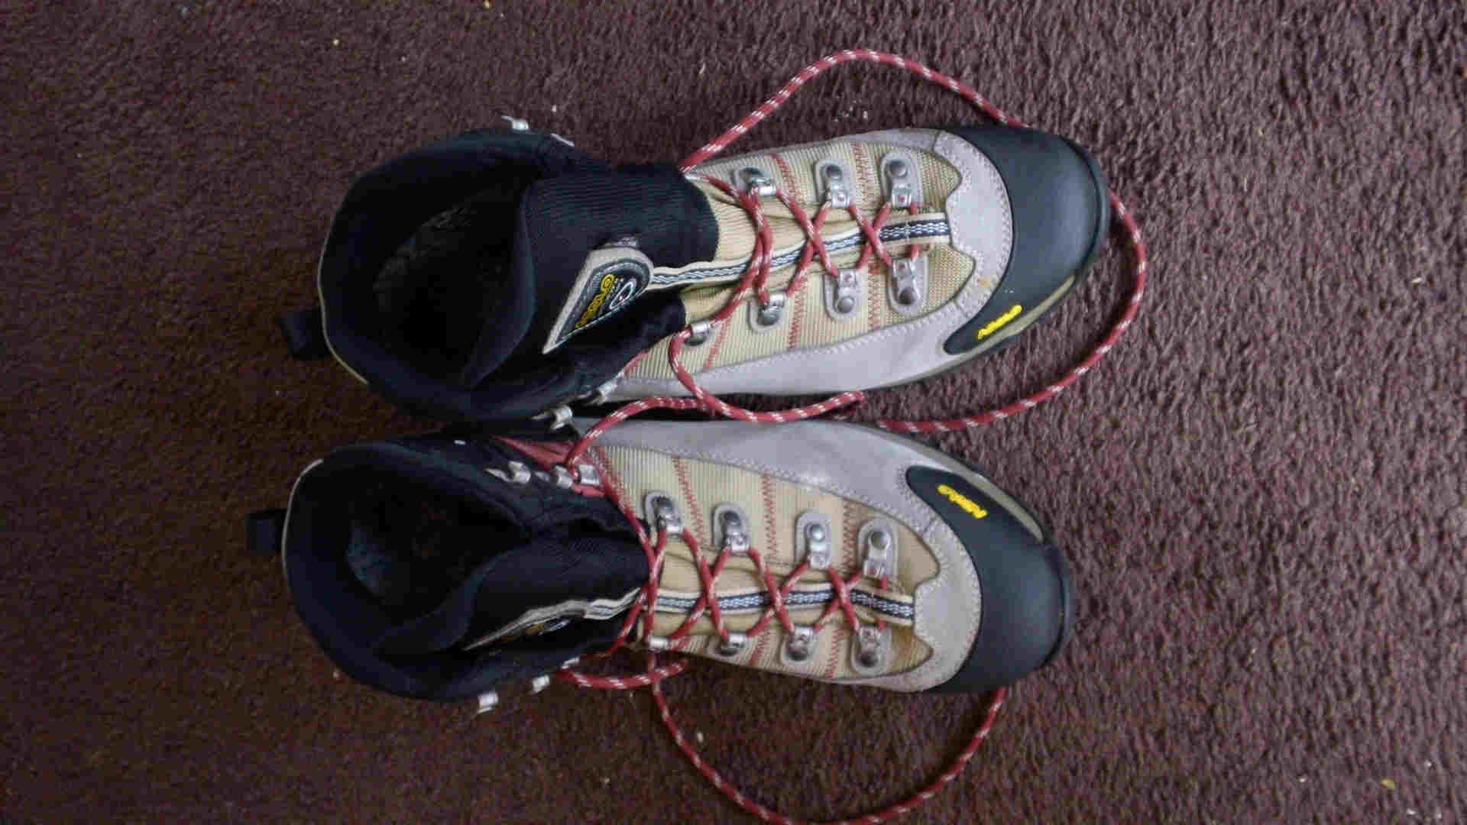Figure 1: The Shoes of the Fisherman? Though, being a size too big (all the seller had), they remind me of them proverbial galoshes, or is it overshoes?
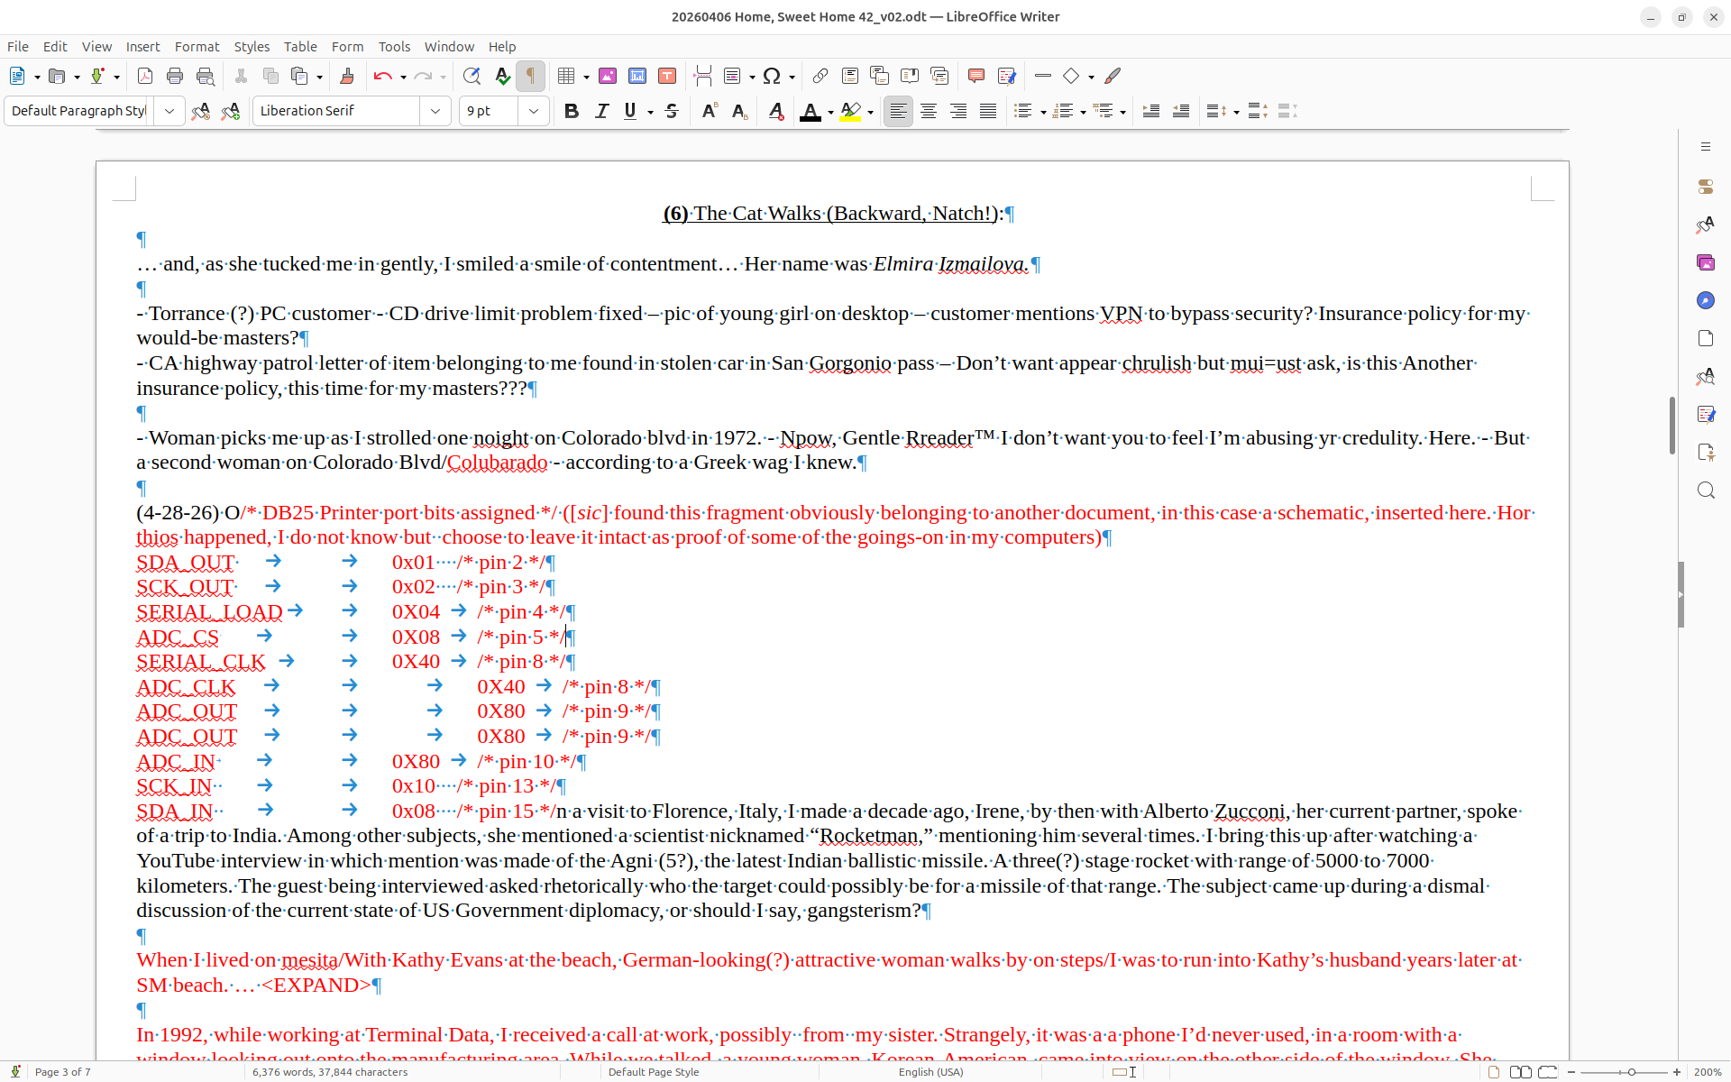Figure 2: Evidence of the increasingly intrusive phenomenon of text fragments finding their way from one document to other, entirely unrelated, ones. Errand sample highlighted in red.
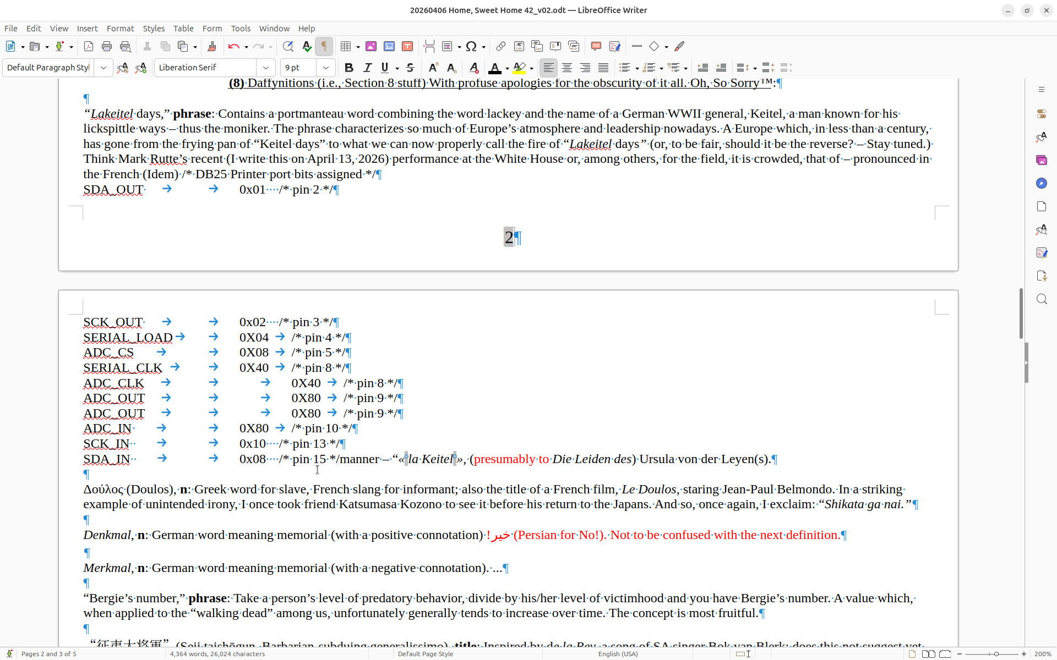Figure 3: Elsewhere in the same document, more of the same. Errand sample not highlighted.
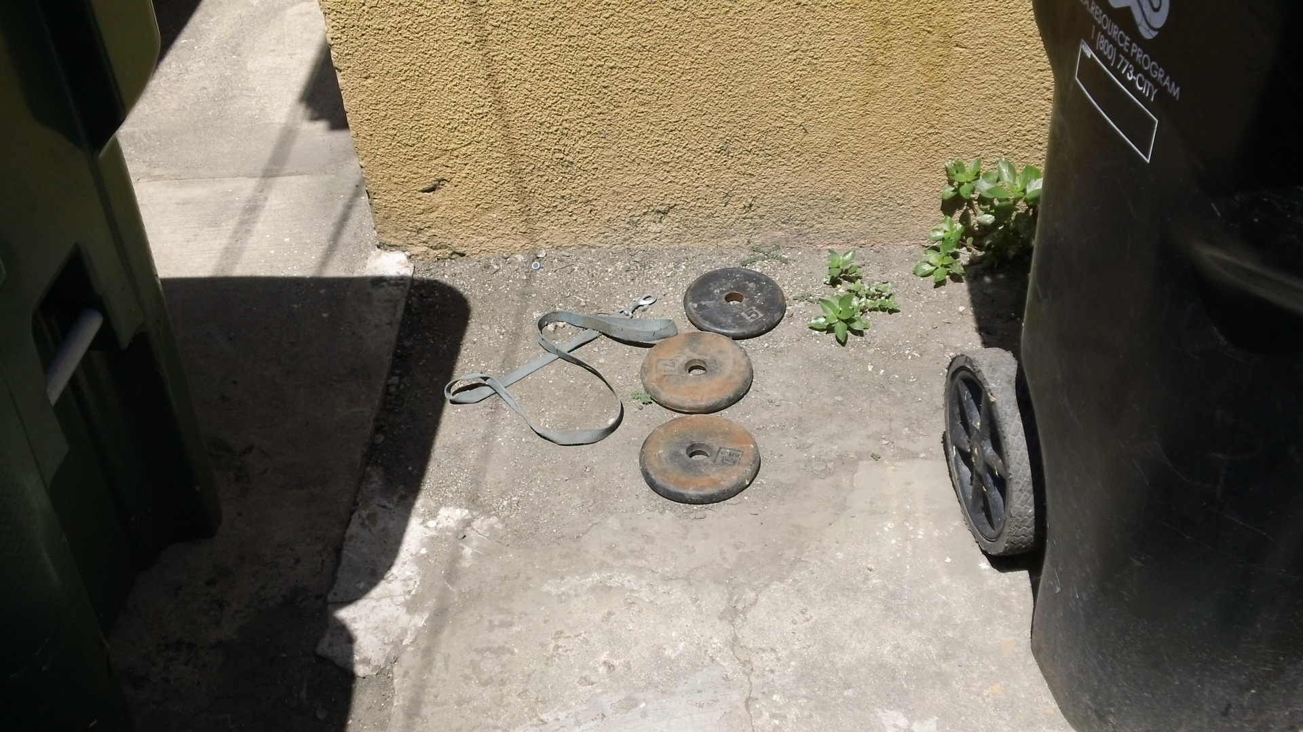Figure 4: On the trail of the rumored weightlifter… <FILL IN>details

Figure 5: Agiter avant l'emploi.
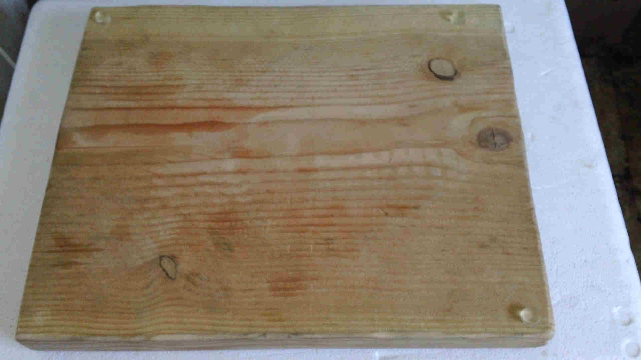Figure 6: A DIY cutting board made of scrap lumber found at a construction site. Notice the discoloration at the lower left, site of one missing plastic feet of the four I’d placed.
Figure 7: The errant plastic foot found! Removed twice from the cutting board in Figure 6, I’ve replaced it twice. One of them reappeared June 15, 2026 on my front steps. I‘m waiting for the other shoe to drop, i.e., for the other missing piece to materialize again.

Caption: onthr right: symbolizing my willingness to air dirty laundry in public. On the left: symbol of this here Republ;ic. Another sight gag.

(18) Beruf: Luftmensch (In which I discuss progress, if any…, on my projects):

(5-5-26) Giving up on my current attempt at making compost. Made mistakes of adding an egg while not ensuring enough water was present. Will maybe try again.

(5-18-26) After a meander through the jungle of DIY NiFe batteries...

(5-28-26) Overall … since I must take into consideration several extraneous factors in my off-grid implementation, it complicates matters. Thus, not the convenience of a “flush and forget” attitude … still workable, though.

Making a virtue of a necessity, I’ve designated a damaged 300W solar panel my “sacrificial” panel, as in “sacrificial wood.” It will now sit permanently on the site of my former pantry, facing south. The heavily cracked unit should generate a few hundred watt-hours each day as it charges scooter battery packs directly. Wrapping it in transparent plastic, I’ve made it morning dew-proof. By also encasing it in cardboard at night, I hope to have made it “Tyson and Son™ proof.”

(19) The Elmer F.U.D. Brigade:

With so much unpleasant business around me, such a negative, poisonous atmosphere, I thought I’d attempt to convey the stress I’m under by summarizing instances of a long-standing pattern, the fostering (in me) of Fear, Uncertainty, and Doubt. Thus the pun with the less than worthy-sounding name itself meant to convey how low some of my neighbors, and others, can get. I’ll update the list of who and what they said whenever required.

(1) Tyson’s son. (2) Tyson. (3) Ms Anderson-Ca’canny. (4) Brother Cantinflas “I’ve got a beef with you, brother.” (It is devoutly to be hoped he does not soon have a cow as well!). (5) LAHD Inspector Reichmann [sic] (6) Spanish-speaking neighbor, a man in the house just to the south of my complex (strolls by as I go into kitchen, says: “Lawyer?” then “No.”) (7) Mrs ‘Bell. (8) Saint Bernard. (9) Tub-thumper’s wife. (10)

(19) Les Lamentations d’un Batracien Désabusé (Credit Ahmed ben Errabeh):

I run on ideological fumes, nostalgia, and resentment. I say fumes to suggest both a certain level of intoxication, paucity of depth, and lack of sophistication. As for the nostalgia and resentment (avant la lettre ?) bits, if you’ve read my stuff, they should be self-explanatory.

(5-12-26) Just had an idea: If things work out, neither this US Government nor I will come out of this with any kind of reputation. If things work out.

Gentle Reader™, a reminder. You may, if you so wish, consider me a (plaster) saint, e.g., Saint Bergie of West Addams [sic]™. Perhaps I could be made the patron saint of, of, of, how about Wayward Negroes, I dunno. A-and, when you say it, do remember to add, under your breath of course, the word “plaster”…

A regret: There are things I wish I’d put in my book. Things which,, precisely because I did not understand the full import of them, would have enhanced my credibility… I omitted them, not out of any embarrassment, at the time, I just didn’t think they were relevant. I forget that I’m not here to think, merely to note...

When I see Brother Cantinflas, this poor creature of the US Government, abase himself in public, every day… I also imagine Father in the same posture; perhaps he, too, was also forced to do so. For him, maybe, in an exquisite way. Mon pauvre Papa.

I’ve often wondered what it must be like to be one of my neighbors, near or far. The best I’d come up with emphasized the “actor’s pantomime.” Since then, I’ve come across another understanding of the predicament, a more awful one. One more in tune with that damned 20th century, inaugurator of totalitarianism. I found it in a book of essays on the Chinese Cultural revolution. Sadly, it may be of some relevance here. From Ley, « Essais sur la Chine. », p.500-501, 1998. Translation mine.

Within the camp………………………………………………………………………………………………………………………………….……...

20) Conclusions or (In the Immortal Words of Soul Brother #1 (oops!) former President Obama) “The View from the Cheap Seats”:

I hear gruesome things about the Russian, Ukrainian, Iranian and Chinese governments. Why do I never hear the like about the US government?

Irene: A father she was estranged from, an unsophisticated mother, a crazy brother she could not confide in. For such people, it must be a lonely life.

There is so much “show” around me; “show” accompanied by so few acts of substance.

When subjected to some of the more elaborate sound montages or late at night, unable to sleep, I sometimes feel like a lab rat trapped in an experiment (run by some of our better-known “schmutzige Magnaten.”? ― “Our recent Rossums” ― For an example, see remarks attributed to Edward Snowden about some efforts carried out on Facebook.).

(21) “Bergie Sez” or Quotations from Chairman Miaou (Those of you with a long memory or a guilty conscience will get the reference):

De Gaulle once commented that while President Kennedy was the public face of America, President Johnson was its private face. I wonder whether our current (I write this in April, 2026) president has not managed to combine both. I’ve compared the Trump administration to Clement Attlee’s, both sets of people at the top were born in a previous century, both thus afflicted with ???, both visibly struggling to balance Means with Empire. At least Attlee’s people had certain qualities. Additionally, though, and in a comparison I consider invidious, Trump’s been compared by a Chinese academic to Gorbachev… Clem, Clem, where are you now that we (don’t) need you?

Napoleon said history is a set of lies, agreed upon. I add that recent history and current events are also a series of lies, the difference being a lack of agreement.

A fine insult: « … idées colportée par les escrocs du type de Liu Shaoqi... .» (… ideas peddled by swindlers of the Liu Shaoqi type…), from Ley, 1972, p.362. A-and here’s another fine insult, this one homemade though derivative: “Oshkosh, b’gosh™!” A-and, folks, if this last one isn’t sufficiently obscure (Nyah, nyah, nyah!), I’ll eat me hat... I must remember to make use of them from time to time.

“If you don’t go crazy, you are not normal.” (Credit Goran Bregović)

Beruf: Schlauberger!
(1) “California: so far from G*d, so near to Mexico.” (2) “America: so far from G*d, so near to Israel.” (3) “This story has more holes than a French tart.” (4) In the false-flag operation I call Unternehmen „Konserven nach Gleiwitz“, with which WWII was inaugurated, the guy in charge of the deal was a fellow named Naujocks. I expect he did OK out of it. Nowadays, though, being a Naujocks could be no joke. (5) Gentle Reader™, which do you prefer: a regime of hoaxers or a regime of Hoxhas? You pays yer money and you takes yer pick. (6) In the interstices between tectonic plates, there may be some freedom to be had. (7) « Au lager comme a la guerre! » (Credit : unknown Russian nobleman on finding himself in the Solovetskys after the Russian revolution). (8) It is a comfort that I, from repeated personal experience, am able to see the US Government as shabby. (9) We live in the land of the almighty lie. (10) Q: Are the Blacks yr brothers or yr friends? A: They are my brothers! (In the Polish sense, Natch!) (11) Not only do I not care whether I win or not but I don’t even know who the various factions are. A-and how’s that for impartiality, i.e., Fiat justicia, ruat coelum. (12) I’ve found it advisable to give these innocents at the USPS a wide berth, for: “U-something!”

My last word in this kaleidoscope of nausea, horror, and malarkey I call Dispatches from the Manchurian Candidate Factory #43:
Lewis Lapham once said that any group of twenty or so well educated people (MA degree, say) could do a better job of running the country than what we’ve had. And that was said well over a decade ago…
Thankyou!Thankyou!Thankyou!

A valediction:
Hoping I remain yr Fair-haired Boy™, I am, Sir/Madam, yr Friendly Neighborhood Paranoid Schizophrenic™ (Better madman than made man, wot?™).
The only things I can say in my defense regarding the above <weasel word warning> inappropriate </weasel word warning> statement: 1) It is heartfelt and sincere, which confession likely aggravates my case. 2) The keyword, part of the title of my book, Schizophrenia Weaponized (free download available), is central to what I hope will eventually become a scandal. 3) It has the additional merit of being true (Credit Richard Nixon).

(signed)
Bergendahl/Berg (as in Nuremberg) “Simplizissimus der Kampfmuzhik™” Hawkins

P.S. To my beloved sisters, Irene (upon whose enemies, confusion) and Colette Walczak (dead of cancer in 2018) and two other unfortunates as well, Mari Berg and Elmira Izmailova: May our wordless tears, yours and mine, eventually prove invincible.

