Home, Sweet Home:
Dispatches from the Manchurian Candidate Factory: #37
A Kaleidoscope of Nausea, Horror and Malarkey

To join list: berg.hawkins@protonmail.com | Site: BergendahlHawkins.com
To donate through PayPal: Berg.as.in.Nuremberg.Hawkins@proton.me
20241015 Home, Sweet Home 37 Fun_v06
Κύριε, ἐλέησον. (Lord, have mercy.)

Midway?
- Initially heading the wrong way, it took an act of insubordination verging on mutiny by one of the squadron leaders, Waldron by name, for some to head in what turned out to be the correct direction.
- The planes his squadron flew had been obsolete since 1939.
- There was no fighter escort to be had.
- As was the quaint custom for torpedo planes, they went in low and slow, please.
- A-and the fact that their torpedoes were generally known to be NFG doesn’t seem to have overly troubled them, neither.
- I give you: Torpedo 8 <insert demented cackle>.

My own opinion (borrowing from Richard Wolin) regarding the stuff I write: “Anecdotally rich but analytically impoverished.” i.e., the view from the trenches Start Date: 10-15-24, email Date:

Distribution: Book group, Addams [sic] Blvd./Cochran Ave. and Environs, FBI & Justice Dept.(by snail mail), Human Rights Watch, LAPD, Landlord, Others.

Purpose: To Ridicule Few. To Amuse Many. To Inform Startle All. A reminder: because of frequent computer malfunctions, when I notice an egregious “printer’s devil,” I’ll bold it and add [sic].That’ll bitch it.

NB: This document is in the public domain. So long as name and content are unchanged, anyone may reproduce it at will. Bergendahl/Berg (as in Nuremberg) Hawkins, Los Angeles, West Addams [sic] District, USA, 2024

That a (Black or considered such) no-talent like me can even be thought worth bothering with by the US Government suggests an unhealthy, maybe even delusional, state of mind among These Princes Who Govern Us™. And so I say: “Bollocks!”

My family’s trajectory, summarized: From (formal) slavery to (informal) slavery in three generations.

“That night his father told his story. He spoke calmly and quietly. What he described could only be spoken about quietly; it could never be conveyed by tears or screams.” ― Life and Fate, Grossman

“There is nothing more difficult to take in hand, more perilous to conduct, or more uncertain in its success, than to take the lead in the introduction of a new order of things.” ― Machiavelli

« Que cet écrivailleur écrive ailleurs. Enfin! »

“Goodness had nothing to do with it.” ― Mae West

“Grazie alla selezione che eseguo, questo spazio è libero dai vari provocatori e malintenzionati.” ― Nicolai Lilin, from his YouTube channel

I always knew I could become like you; I was once afraid I might.

(1) Summary of Contents:

(1) (2) (3) (4) (5)

(2) Tales of Tylenol (my evil twin, Tylenol Hawkins, that is) or The Kompromat Korner:

<TELL> ...You can’t cheat an honest man (Credit WC Fields).????REMOVE??>

<TELL>… Then, from I don’t know where, I heard a “Noooooo!” echo through the canyon of Addagastritisms [sic] Blvd. And so, properly chastened I, meekly, I continued on my way. Qu’est que vous voulez, ce mec me dévisageait !

I ripped off Akram… (did not treat him fairly) <TELL>

(3) Plumbing the Depths, (Pukka) Wanker that I Am:

Watching a YouTube video: “FAT: A Documentary | Health & Wellness | Weight Loss | FULL DOCUMENTARY” by Gravitas Documentaries I ask myself:
Was I once baited by a customer with T2D into being overly critical of the medical profession? Here’s how it happened. After some irrelevant(?) other skits”, Once or twice he came to me with news of having been prescribed diabetic shoes, I’d previously seen a nurse visit his house to administer antibiotics by IV. Once, as he left my steps, I felt I had to help him step down by slowly walking ahead of him. On his next visit, I not able to restrain myself; lecturing him on the worthlessness of conventional T2D advice, explaining what my own solution was. I now suspect him of exaggerating his symptoms, perhaps in a bid for sympathy in order to bait me. Folks, don’t get diabetes if you can’t take a joke. I tentatively expand on that last statement by including citizenship in this here Republic...

During a visit to a customer, one of the employees said to me, unbidden: “You think you are better than us?” As close to a forthright cry from the heart as one is likely to hear from any human being oppressed by the US Government. To think that my sisters were/are in exactly in the same position. Names available.

(12-020-24) … Aftyer yesterday’s “shaggy dog-type” broadside freom Saint B., to-day, Brother C., by comparison, was a study in contrasts, keeping it short and sweet, ‘e did. Fter whioch mI ran some errands. … In shorft, business as usuaL.

(4) Errors, Corrections (Lost & Found), Clarifications and Amplifications (A new section in which I acknowledge, among others, prior mistakes):

I’ve resented the fact that oh, so solicitous prof Humphrey/Beckman duo make more than pleasant noises within earshot of me. But then again, had they done so, I might have gone the way of “Taj.” Were they aware of him? I was; yet almost even half a century later I still persisted in holding on to my car and bike...

(5) To my Landlord, AFJ Investments. One in an Occasional Series:

(11-22-24) As LAHD case # SO302426 for illegal rent increase made its way through the bowels of the LAHD and was finally was resolved in my favor, can I expect a prompt refund of the $53.64 you owe me?

A term I come across from time to time: “Hybrid war” the sub-category of “Lawfare,” from my limited understanding is illustrated by what happened to Evo Morales. I wonder if they can apply to the problems I’ve had with you? A LESS POLITE WAY WOULD BE TO SAY “FORMAL THEFT.”

(6) The Cat Walks (Backward, Natch!) or My Life Story Seen as a Fractal:

I’ve just heard of a new term, “Surveillance Education,” from the Chris Hedges Report on YouTube. Applied to my interactions with Robert Seidenstein when, as a sixteen year old, I was targeted by the US Government while living in Germany.

Though I think highly of Janusz Vacłav Hetman, there are, however, several strikes against him to consider:
- Made crude, obvious passes at me during our early meetings. Though they were never again erepeated.
- Tried to get me to “lend” him my resale number”
- Spoke of Renee Chaba in a surprising, insulting way, referring to her as “that old bitch.” For him a startling command(?) performance.
- Suspicions of occasional sabotage of small projects I’d brought him??
- Then that visit to a restaurant owner by a Polish man whose daughter serving, avoided my eye throughout???

Carole Stein, my cousin from Paris, once visited us in Bremerhaven, West Germany for a few week’s. As I soon heard (this in the seventies), she said of me: « il fait très bébé » (he looks very infantile). (Then) apt (of her) and (now) apposite (of me), for is it not said that the truth shall come from the mouth of a babe?

Though I’ve grown used to revealing embarrassing things about myself and no longer think much about it either way, I’m increasingly disturbed and ashamed of one particular incident. An incident in which, if I’m not delusional, I was used to frighten/caution the founder and head of a publicly traded company. If I’m right in this, this place is indeed where “one man laughs and a hundred cry” (Credit Solzhenitsyn). Gentle Reader™, I’ll do the facts, you do the rest. Period.

(1) At school, Willard Brown quietly let me know that Dabney House RA, Finn Ravndahl’s, wife Elsa(?) was available. When I declined to partake, her husband went out of his way to shake my hand. (2) Living on Mesita Rd., a woman I was attracted to gave me lessons for some weeks until I stopped attending. I knew her husband, a man who had shown me some kindness. (3) Much later, a secretary, wife of an employee of the pellicle mix manufacturer owned by Ray Wynn, I worked at in Burbank, also made herself available. Again, when I declined her kind offer, her husband, also an employee, went out of his way to shake my hand. (4) Matt Moran‘s wife signaled her availability by the simple expedient of blowing in my ear when her husband conveniently stepped out of the room. To my shame I responded positively. Her husband, making excuses for me, said: “At least it didn’t work the first time.” In the past he, too, had been very helpful. This fairly establishes a pattern though, at the time, I didn’t pay it no never mind. C’était peut-être pour mes yeux bleu, qui sait?

In 1995, during my seven month stay in Florence, Elie Cathala [spelling], a longtime friend of the family on mother’s side, attended a trade show in Milan(?). Though I was hoping to see him, Irene let me know otherwise.

Incident w. Ruth, 1) intro? by Ellsberg, 2) her behavior on return when I was left alone in her house w. daughter in next room. 3) Her friend’s wounding comment. Objective facts, revealing what I am & what I’m seen as. So You, gentle reader™, can have an objective idea of what I am and what we aall re dealing with in regards to These Princes (Desperadoes?) Who Govern Us™.

(1-7-25) I’d complained to Caltech’s Lee Browne that Father was wondering why I was doing so badly in school. His immediate reply: “Tell him: ‘It’s a bitch, daddy!’ Use those exact words.” If I finally understand him correctly (I point out here that this happened in the early seventies, i.e., “Now I get it™”), I’m starting to think this place is a barefaced scam, is it not written: “Chi disse donna disse danno!” Funny, that! Is it any wonder that the second oldest profession would have found a use for the oldest? A-and to our Gentlemen of the Organs of State Security™ (and the US Government, in general), aside from the occasional Oh! so self-satisfied, smug, smirk, I. Won’t. Let. On. You can trust me on this...

(7) Running the Public Transit Gauntlet or “Prendere in Giro” (An Italian expression meaning to tease/take someone for a ride(?). In my case, literally):

(11-21-24) …
- CC #1, ID 7154 at <3:58PM. After I’d made the hitchhiking sign as bus approached and the bus had stopped, I asked for the ramp. He driver lowered it although I’d warned him it wouldn’t work. He ignored me then, with the ramp showing a gap of 6” to sidewalk becauise of relative heights of bus and curb, he said helpfully: “That’s why they don’t want to give you the ramp because this always happens.” I replied: “Good. Thank you before sitting on the bus bench again. He pulled away.
- CC #1, ID 7137 at 4:24PM.I asked for the ramp , she said something, I repeated myself, she said something more. A third time, I asked “Please lower the ramp.” She said: “Are you not able to [rest unclear].” I replied: “Well, you do your best.” and sat down on bench again. She pulled away.
- CC #1 ID 7152 at 4:53PM. This one did stop. A shame, really, as I was prepared to make one of them auto-da-fé out of it (walk home). Coriace , le canasson, pas vrai? Additionally, and this is not to prejudice yr judgment, Gentle Reader™, my dolly was carrying 32.2lb of groceries. A-and are we having fun yet?

Returning from Costco, having just stopped at Trader Joe’s, I tried to board a Culver City bus with my loaded dolly. Twice asking for the ramp, I was met with an apologetic: “the curb is too high.” This after the driver had obligingly (but who, exactly, was she obliging, Eh?) kneeled the bus to below the height of the curb, making it impossible for the ramp to pivot completely to the sidewalk, the resulting gap would have prevented the wheels of my dolly from bridging it. By now, in full 無為 (wu wei/action-through-inaction/passive-aggressive) flight and with, in retrospect, unseemly alacrity, I quietly replied: “Thank you!” before walking away. Pausing at the next corner for some specifics, the bus, after a while, finally drove by. I manage to get its ID and, as my grandfather used to say in his poor French, « C’est lo principal. » After which, seizing the moment, I carried out another of my notorious auto-da-fés (literally: act of faith; figuratively: don’t ask), walking the rest of the way. Some particulars: 11-29-24 @ 5:17PM, Culver City bus #1, ID 7121, 15770 steps walked for the day, my dolly weighing 50.2lb. A-and are we having fun, yet?

(8) Daffynitions (i.e., Section 8 stuff) With profuse apologies for the obscurity of it all. Oh, so sorry!:

Bedside trimmings, phrase: (1) At Cafe Santa Monica w. Kitaw Ejigo (sic, I’d meant Ejigu) (2) At Norm’s/La Cienega next to a poor f****r of the Israeli persuasion and an American girl (3) Colette’s late, surprising offer of a bit of the old in-out, in-out? I dunno. (4) I may have witnessed the aftermath of such an Aktion., at Norm’s on La Cienega when I still lived on Garth, an Aktion involving a young American woman and an Israeli of about the same age. He seemed poleaxed, the poor fellow. Furthermore, I dunno about this place.

SRDS, acronym: Watching a 60 Minutes in-depth investigation of an SRDS (Sudden Russian Death Syndrome)) case in Alicante, Spain, vacation spot favored by Russian expats, I was both impressed and depressed. Impressed by the quality of the presentation (and, truth be told, the looks of the presenter, one Cecillia Vega) and, simultaneously, depressed by both the subject matter a-and the quality of its presentation (these poor Russian f****rs don’t stand a chance in this arena). Why, this happened near mom’s own home town of Finestrat, Spain, too… Assassin, victim of character assassination, statesman(?); I give you Putin.

Naseschleimentladungsgesicht, n: German for snot-face. Now I ask you, Gentle Reader™, does this sound like a reasonable language? I‘m just askin’.

Les Lamentations d’un Kamikase (A Kamikaze’s Lament), phrase: “No dying to-day! No dying to-day! So solly!” (Credit Pynchon). Pronounced, of course, in a sing-song (so huuuurtful, innit?) voice, Natch! For me, though, a daily affirmation of life (both the lamentation a-and tone itself).

Lord Byron, proper name: I’m like ‘im in a cut rate, downmarket sort of way. Both of us quite literally: “Mad, bad and dangerous to know.”

Langley Marriage, phrase: Like a Boston Marriage, only one of the participants often has the opposite polarity. The Stasi’s Markus Wolf was a devote of the art.

Kvetchgesang, n: When Mrs. ‘Bell decides to unburden herself of a morning, she unfortunately often chooses to do so: (a) Loudly (b) In front of my bedroom window (c) If Saint B. chooses to join in, I can then no longer sleep. Sigh.

Peasant, n: A creature found cumbering the lower strata of Hive Cities on Planet Kaputt™. And no, this is not a (video) game; allow me. Coming in two flavors: the Peasant Tout Court™ and the Peasant Malignant™, I offer contrasting and illustrative examples. My life (for the Tout Court™ variety) and that of my sisters (for the Malignant™ kind). A-and, to anyone questioning my right to categorize, I say: “Wer Bauer ist, bestimme ich!” (Credit Herr Göring, slightly modified...)

Sardines, n: Ordinary fish which, in the mouth of our Saint Bernard™, become a telling non sequitur. Go figure. Alternately, you might ask the Saint for an explanation...

Faux(?) muzhik, phrase: A literary style characterized by a peculiar compound of obscurity leavened by silliness and inanity with equal parts of provocation for good measure. A style I’ve made my own.

(9) The Eccentric Shaft™: Dubious Interactions with my Fellow Crazies. A-and me a Paranoid Schizophrenic, Too (Credit: Irene Hawkins, personal comm.):

(12-5-24) The local yokel locos are much quieter lately though some “sync” noted.

(12-7-24) Throwing in the Towel? A skit in 4 parts, timeline below:
- Corn-fed Golem™ Tyson’s son “the Tiny Terror™ blocking my way with dog on leash, says loudly: “Hey! I’m telling dad!” as I walk by. This is the kid whose father the LAPD refuses to arrest. We are in “Bozo Zone” territory, now. I declare!
- I put a towel out to dry on fence. The Tiny Terror™ soon comes out, babbling gibberish as he walks his dog.
- I later find my towel dumped on ground, dirty and return it to where it was.
- Later, outside to test a solar panel on my steps, Ms. Mumbles walking up to my turned back, startles me with a loud: “Hi!” then says: Do these fit?” (referring to some clothing items she’s carrying), puts them on fence. I later find my towel again off the fence, lying on bushes, but cleaned a bit.

(10) La Rubrique des Gueules Cassées (A Section on War-wounded):
There’s method to this madness, I daresay. « On fend le bois avec un coin en bois. »

I was going to quote some cryptic exchanges verbatim, but, in the interest of my soul have decided to forgo the opportunity. See below for a reason.

My hospital shall, henceforth, if I may make so bold, be known to me as Kaiser Permanente Matanzima (Land of the Upright Coke Machines™ <insert demented cackle>). And, just as I do not stoop to identifying “malfunctioning” bus drivers, regarding creatures found cumbering Kaiser Matanzima lands, hier bleibe ich auch stumm. However, should I perchance have occasion to ever call on that lot again, I may innocently ask: “Is this Kaiser?” Before adding: ‘Kaiser Matanzima?” And after the inevitable denial, hang up with: “I/you must have a wrong number.” Non, mais!

Spilling things more often, maybe a bit more difficulties with balance. Weight stuck around 160lb, BP normal though very variable at times. Sniffles.

A YouTube video, https://www.youtube.com/watch?v=cn3saHxz5hw, “The Most Important Step in Mental Health Care That No One Tells You” by a schizoaffective woman makes a telling point, a conclusion I’ve also come to, though in another area: my diabetes. I think the most important step in my “fix” was a decision, nicely summarized by the motto of the Enlightenment: “Audi Sapere,” meaning “Dare to think.” Notice that they did not say “Think,” no, they were cleverer than that. Implied by the word “dare” is risk. The risk that when we think for ourselves, we usually get it wrong (I know I do). So why bother? Well, when we let others take on this burden, we risk having them set the agenda as well. And that is never good. This woman, if I understand her, puts at least some of the onus for change on the individual suffering. There may be wider implications in this thought...

(11-28-24) Written at 3:56AM. The strangest, most physically uncomfortable day & night in my life. Starting at around 7:30AM yesterday, when, still in bed, I began hearing noises from the construction site across the street at the partly completed apartment buildings: 2637 S Cochran (possibly wrong address as directly across street is 2638 ½, a blue house) and net to the mostly finished house is another, still under construction with the one just to the north is 2629, an old house, single story, anomaly? Coming from the work site were sounds I’ve come to associate with the place. (1) A light, repeated, rapid, to me pointless from point of view of construction work, tapping. Tap-tap-tap, regular as a metronome, pausing, then repeating itself. This sound went on until past noon, intermittently. (2) Another characteristic noise was a light grinding high-pitched sound, coming from a tool rubbing against metal, sometimes for extended periods, mostly brief single sounds or rapid bursts, always very light, also pointless-seeming. I went there to look the place over & came back to dismantle some metal pieces from a bed frame lying discarded on grass across the street. Did not speak to anyone though there was some of what I call “whooping it up” from workers there, sync occasionally noticed.
I had a headache from the time I got up & took an aspirin which did not help. In fact, I began feeling worse around noon. The odd construction sounds stopped in the early afternoon. Saint Bernard & Mrs. ‘Bell mostly, but not entirely quiet throughout. Then music started, at an increasingly high volume. I had gone back to bed w.o. coffee or a meal, began to feel worse and worse. The music continued, starting around 1PM, almost non-stop until midnight. Before midnight I began hearing a man’s voice, it went on for a long time, in a tone which carried. He spoke non-stop before being joined by a woman’s voice. I could identify her as Mrs. ‘Bell. She got louder until, at times, she was screaming. Obscenities were often used, the music mostly on, loud, of the “hum & thump” variety. At times extremely loud! At 2AM, I could still hear her, possibly the man as well. He bid her farewell from the walkway, in a loud voice: “See you later [or] take care, momma.”
Now as to me. I had been in bed from 1PM on, with an increase in: (1) nausea (2) headache (3) spells of dizziness lasting less than a second, intense and repeated ~12 times (I’d have fallen, I think if I’d been standing) (4) joint pain – in my elbows though I tried to keep my arms straight (5) A pain in my left hip, severe. (6) Numbness/tingling in fingertips – though not much unless I lie flat on my back. (7) Sniffles. I eventually used my Diclofenac which may have helped. There was mostly silence after the man left. I got up at about 3AM, right now, I feel no dizziness, no hip pain, no joint pain, only slight headache, only slight queasiness. All in all much better! It is silent outside. I still feel weak. (Update 12-3-24) After a couple of days in which I felt queasy at times, especially after meals, got up this morning feeling file and, after my one meal today, continue to do so.

The nausea is similar to, though more intense than, what I experienced after my neighbor the Corn-fed Golem™ Tyson, once jostled me off a ladder I was perched on while putting up fliers just outside out complex. In a visit to Kaiser soon after, a doctor suggested my symptom might be psychosomatic in nature.

The reply I got from Irene after I sent her the above: “Dear Berg, just finished reading your last emails and hope you’re feeling better. You may want to consult with both your medical doctor and your psychiatrist as to what may be the cause of the intense discomfort you experienced, especially if it is recurrent. Keep me posted. Baci, 😘 i.“ Aside from the lack of sympathy in her tone, something I was seeking, this is the kind of distancing, a stilted and somewhat formal language I remember hearing from her when, in 1988, while hospitalized for my first psychotic break, I complained my glasses were missing. Her reply or words similar: “They became broken and had to be disposed of.” Another, more practical, objection is that whenever I go to Kaiser Permanente Matanzima, my blood pressure (literally, see a previous HSH) goes up by 30 points. Berg not lie. And then, there’s the small matter of the, to me, somewhat rough handling I received at their hands the last time I “consulted” them…

(My)… Paranoia, superstition and pointlessness. But can I really be blamed? They spoke of the reality distortion field which surrounded Steve Jobs; I believe I, too, have such a field surrounding me. Difference is, unlike Jobs, I didn’t create it, it merely follows me wherever I go. … “narrative in my own head? <EXPAND??>
<TELL>. See especially this fine piece: https://calteches.library.caltech.edu/51/2/CargoCult.htm

Whenever I check on a recurring scalp itch, with one recent exception, I find nothing though my head often itches furiously. Psychosomatic?

(11) The Quotable Other with “Tales of the Himmelfahrtkommando™ My Most Sincere & Devoted Friends”, i.e., My Poor Neighbors’ Antics:

… <TELL> Roberta,Flo? … And so yr Friendly Neighborhood Paranoid Schizophrenic™ once again forced to read tea leaves. I’m confused, sorely confused.

(11-22-24) On a Friday, several weeks ago, the wife of the neighbor I’ve nicknamed “Tub thumper,” moving some trash bins up and down the street, unusual for her, stopped to remind me, apropos nothing I can remember, that I’d have to go in. Yesterday, coming home with my dolly loaded with groceries, I stopped to hand out a flier to a parking valet. After thanking me, presumably referring to my load, he followed me to ask if I “was selling out/it” before correcting himself: “Oh, you’re going to eat it.”

(11-25-24) Day and night, around the neighborhood, I hear mysterious, superfluous, slight sounds and, in my bungalow, items of trivial value moved or removed. All this, when combined with the more, shall we say, obvious antics of Mrs. ‘Bell, Saint Bernard and others only adds to the surreal impact of the peculiar atmosphere as no one, not a single witness to this daily circus, ever seems to notice, let alone comments.

(12) Les Casses et Déboires de l’Oncle Sam (the first implying the second) (Uncle Sam’s Robberies and (Other) Mishaps (Credit: Stowe)):

(11-21-24) My refrigerated water shower setup with nozzles and frame to hold them, pump and bucket for water no longer works. Pump won’t start anymore. In a recent visit to the optometrist, I was firmly told to use hot water compresses. My eyeball warmer no longer works though I’ve even tried connecting it directly to a lab power supply instead of the USB-powered computerized gizmo it came with.

(13) Sassenach™ and His Yankee Damyankee Tricks:

Watching a 60 Minutes program on assassinations carried out under the current Russian regime, I’m appalled and awed. >EXPLAIN> …Provocation around here now so blatant, I can truly speak of a circus….. The “Flip Side” of Zersetzung, or “the Long Con.” where by dint of repeated, plausibly deniable, mine-de-rien, social engineering, a person not only may become unbalanced but can also be made to look it.

Bonito flakes out of season? I merely speculate here.
(11-22-24) At the H-Mart on Western in Koreatown today, though I looked everywhere, there was no dried Bonito to be had though I’d previously bought some. Giving up, I took my other items to the checkout line and asked the cashier whether it was in stock but, on hearing “Huh?” and seeing the look on his face, I quietly thanked him and turned my back to lean against the counter while he rang up my purchases. And, when asked, twice, whether I wanted a bag, my reply was merely a “No” followed by “I repeat <---- Ganged 12 Pole SPST Knife
Switch Emergency Shutoff [an egregious sample of the sort of printer’s devils bedeviling me lately. A fragment mysteriously transposed from another document altogether] myself, no.” Not about to give up, I then parked in front of the manager’s booth, but the older woman who eventually wandered over was unable to help much, either. I notice she was the same person who, about week ago, had gone out of her way to be helpful when a clerk neglected to wrap a plastic bag around my gallon jar of kimchi to keep it from leaking into my grocery bag. There were no arrests.

Calls or emails not returned: (1) DWP and a dozen other people/organizations, on guidance regarding “solar for renters” law (2) Bill Elarton, LATTC, on welding classes (3) Lisa Legohn, LATTC, on welding (4) Robert, Craigslist/Fresno, on solar panels for sale (5) Jon Howard, on electrician rates (6) West Adams Neighborhood Council (7) Caltech, numerous (though not all) support personnel, on contact info & request for help on setting meetings.

(11-28-24) Not for the first time, I’m unable to mail a package to Austria, order # 09-12382-10616, item # 235561604303, date sold: Nov 28, 2024. See attached screenshot. (Update: 12-6-24) With help of eBay customer service (second helping) I was able to mail it, we’ll see if it makes it to the customer.

(12-22-24) Spent part of a cloudy day sitting in my folding chair, outside by the curb, sipping coffee, occasionally working on some carpentry nearby. Earlier, unable to find my original copy, I’d reprinted a couple of poems I hoped to memorize. When I looked for the index card later in the afternoon, it was gone. The card, other papers, a binder and my chair, had been outside all day. Someone’s been parsimonious in his larceny. The poems: Kipling’s If— and Arithmetic on the Frontier.

(14) Benelux: A Kushi, it’s True, but a Nice One:

When they fail to appreciate my sophisticated, Oh, so subtle™ witticisms, e.g., introducing myself with: “Hi, I’m yr Friendly Neighborhood Paranoid Schizophrenic™,” I console myself with the thought: “Quod licet Jovi, non licet bovi.” Understandable, really.

When the thought of running for office pops up in my occasionally swollen head, I remind myself that the position of court jester is not elective; usually considered an appointive position.

(12-16-24) Went to a West Adams Neighborhood Council meeting tonight, one of Edmund Burke’s “little platoons.” I note that one attendee brought up a frustrating problem with a neighbor’s noisy dog while another asked for details on construction work near her house... As for me, Ich blieb stumm, of that you can be sure. A-and confess to having dozed off at times, I simply wasn’t prepared. Next time, though, I’ll be loaded for bear... I’m bringing a pillow.

Been watching a so-called “Krabbe Aktion,” a scene in which the authorities engage in a spot of urban renewal (SA style?). From that fine 2009 film by Neill Blomkamp: District 9, I play it with the soundtrack muted and the ride from Die Walküre and, following colonel Kilgore’s wish in Apocalypse Now, I make it loud. Great fun! A (non-ironic) aside: Blomkamp turns suffering and messages into entertainment; that, too, in a slapstick, crude sort of way, is also one of my aims.

I feel lucky and privileged. I don’t have to lie, not to anyone, not about anything. The converse is also true: because I don’t lie, my luck holds; for as long as I continue, that is. It also occurs to me that I shouldn’t abuse a privilege of inestimable value by being so exaggeratedly and needlessly truthful that I make people uncomfortable. Ha, ha, ha.

(15) Juegos de Manos, Juegos de Villanos:

Has walking on the wrong side of the sidewalk become a national pastime? I merely ask.

(12-??-24) The Tiny Terror™ struck, again. Walking by my window as I worked, he, after his customary stroll in which he mutters to himself or spouts gibberish, threw something at my window (sans mot dire), after which I saw him glance back, perhaps to gauge the effect of this latest provocation. I’m sending a summary of his behavior over the years to the Edelman Mental Health Center for Children in Culver City.

(16) Shooting Fish in a Barrel I am, a-and Getting Pretty Good at it, Too (e.g., Bus Driver’s Words: “We Don’t Need Your Mouth.” Had I Hit a Nerve?):

Whenever, morning, day or night, I hear Corn-fed Golem™ Tyson walk by, cursing up a storm in Jamaican(?) patois, I think: there goes my most fervent and sincere well-wisher.

I’m taking a leaf from Einstein who, while still in Germany, used to amuse himself by attending talks where speakers would rail against something called “Jewish physics” or the like. So, lately, I’ve been paying closer attention to the “Kampfmusik für der Kampfmuzhik” accompanying me wherever I go.

You wanna know something? I’m starting to think my middle name is “cabrón!”

Was thinking, we of this (partly) self-inflicted Bashi-bazouk (an epithet invidiously applied by Tito to Hoxha’s paradise) Republic™ deserve better. As these newfangled experiments are demonstrably failing the world over, mebbe something a bit more traditional is called for. Something along the lines of a return to constitutional monarchies, with a king/queen and such (may I put my name forward for the post of court jester?). Also, as one of my self-inflicted nicknames is “el Descamisado” (a term of some contempt, down Argentina way) and considering “my” song (of resentment) is by Johnny Paycheck, it is in the logic of the thing that the name Evita would pop up. Queen Evita, that’s the ticket. Queen Evita Bezuidenhout, that is. God save the Queen! That “Happyness in Gazankulu“ might reign at last!

(12-13-24) An impromptu, slightly corrected, email to Irene, sent today:

Hi Spieß!

I recommend a Norwegian film, The King’s Choice, https://www.youtube.com/watch?v=FrtZEYgcaIk; I watched it last night. It tells the story of how Norway reacted to the surprise invasion by Germany in 1940.

I don’t expect the King, Haakon VII, did his sums, first calculating the odds of Hitler winning the war, before deciding to have no truck with the Germans or one such as Quisling, the usurper who organized a coup as the country was being invaded.

Neither did the commanders of the forts guarding the entrance to Oslo do their sums. Without hesitation or even a warning shot, they (unfeeling jerks!) began firing obsolete canons and torpedoes at Germany's large and modern warships, to devastating effect. And, after the war, were both decorated with Norway’s highest military honor.

As for me and my travails, I expect to eventually be awarded the Cross of Bugs Bunny wiv’ Carrots, Hollywood’s highest. Nothing. Less. Will. Do.

A-and, as you may remember, I never properly learned to do me sums neither (in my case, long division ― whatever that is). No doubt, as I’ve previously alleged, on account of a racist system…

Film is in Norwegian, Danish and some German, English subtitles throughout.

Enjoy.

I’m off to my doctor’s appointment, now.

20241227 King's Choice_v02

(17) Pics:

Figure 1: Once again, could not ship an item overseas, days later, was able to, though for $5 more. An infrequent but persistent malfunction in eBay’s software.
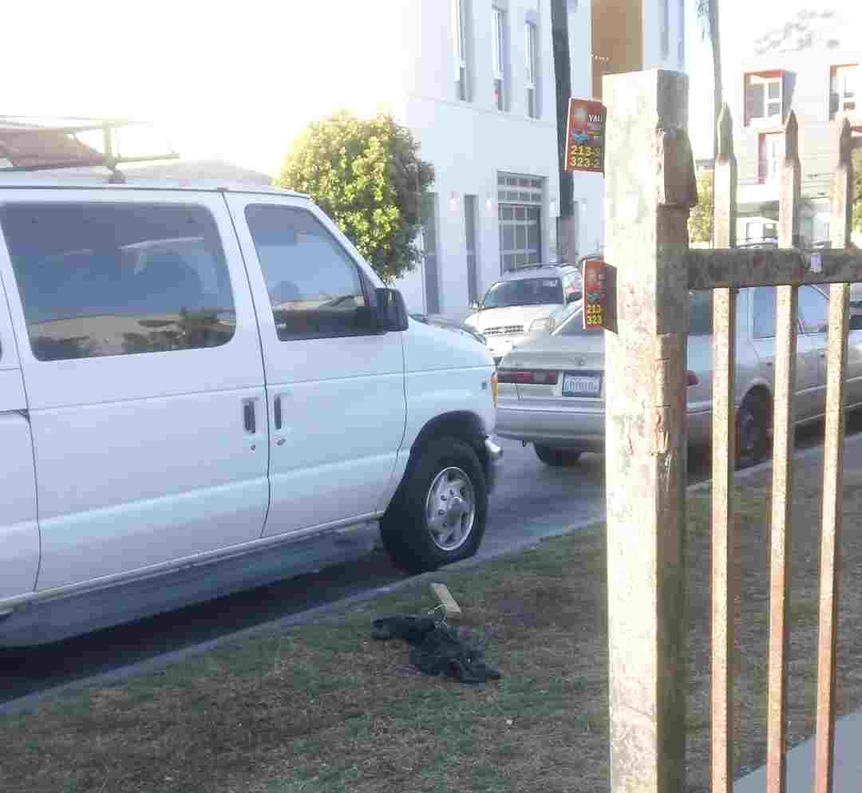Figure 2: Pic of a towel I was drying, dumped on 12-7-24.
Figure 3: Towel's original location.
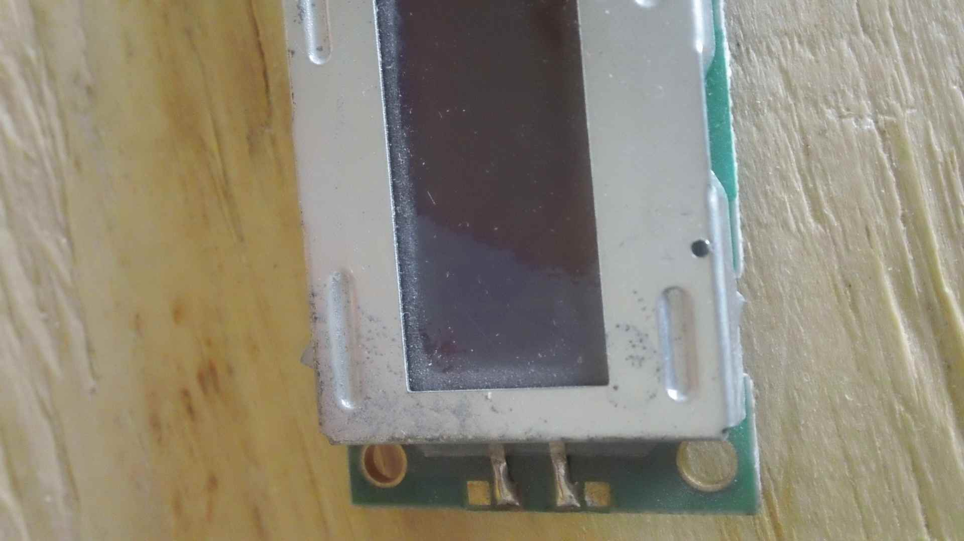Figure 4: Broken LCD display.

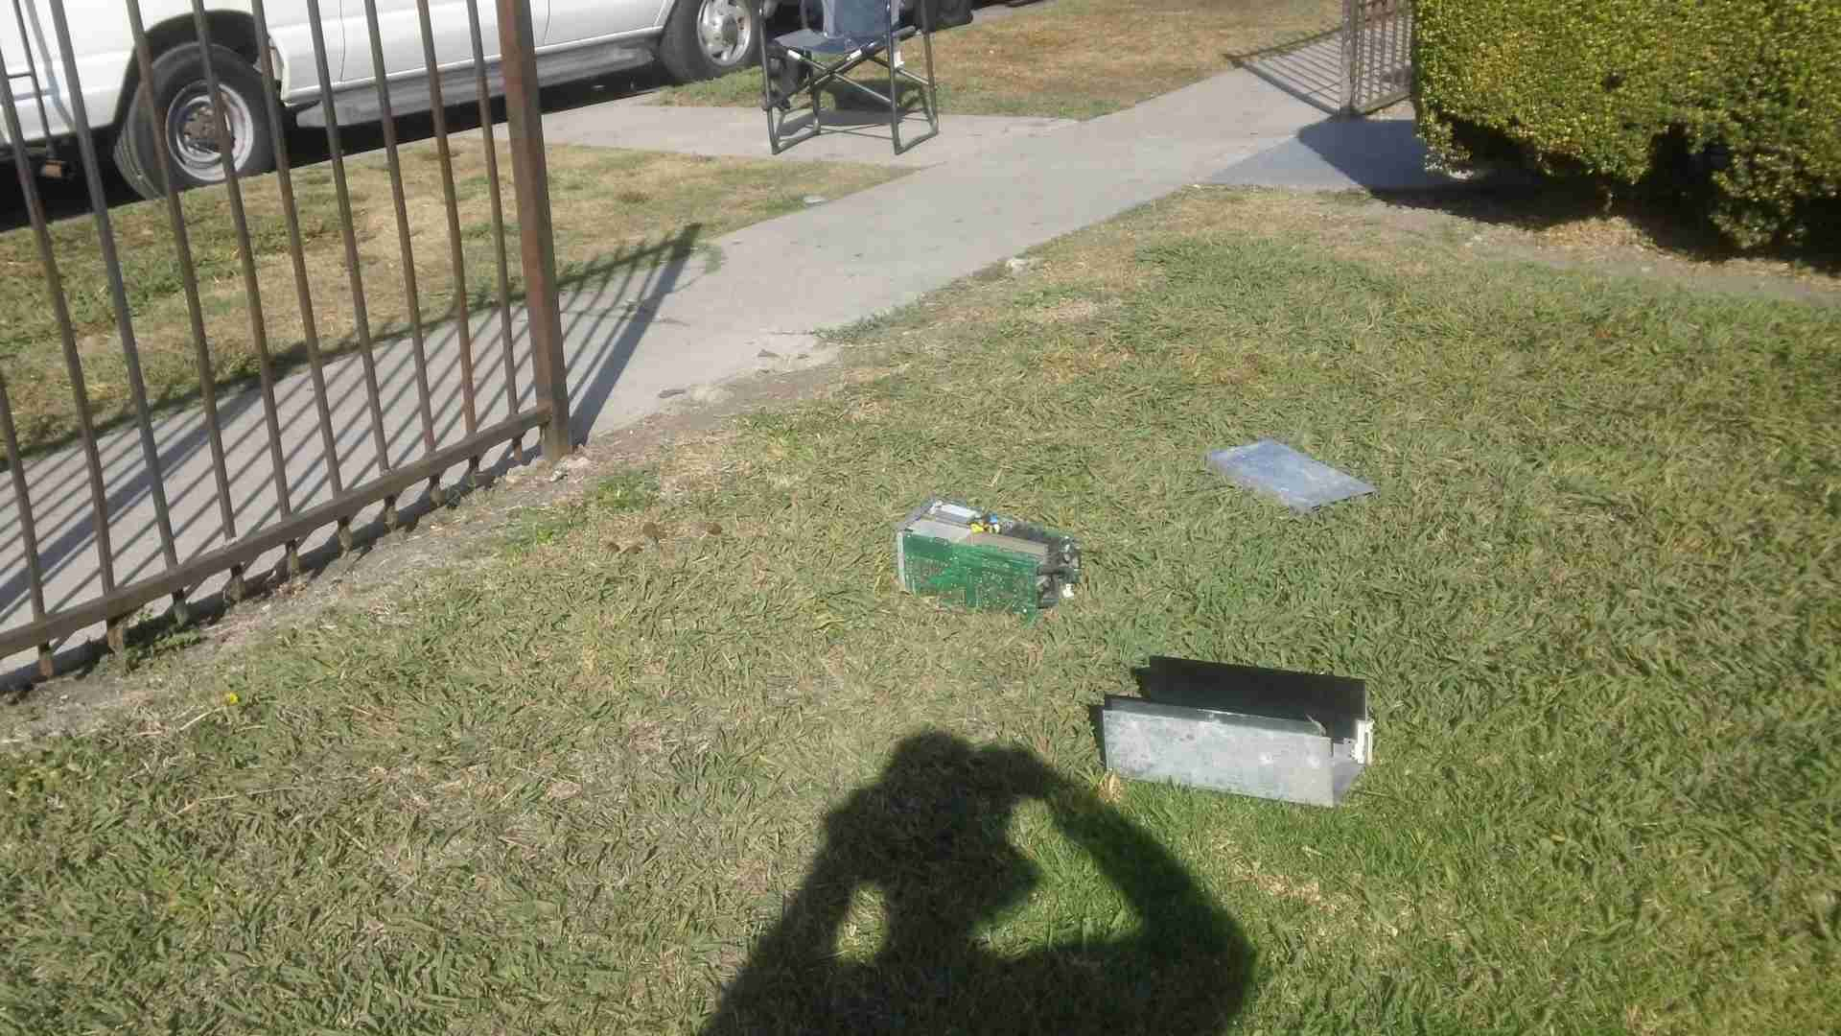Figure 5: Power supply, another item I'd been trying to donate by leaving it at the curb, thrown back on the lawn in front of my bungalow on 12-21-24.
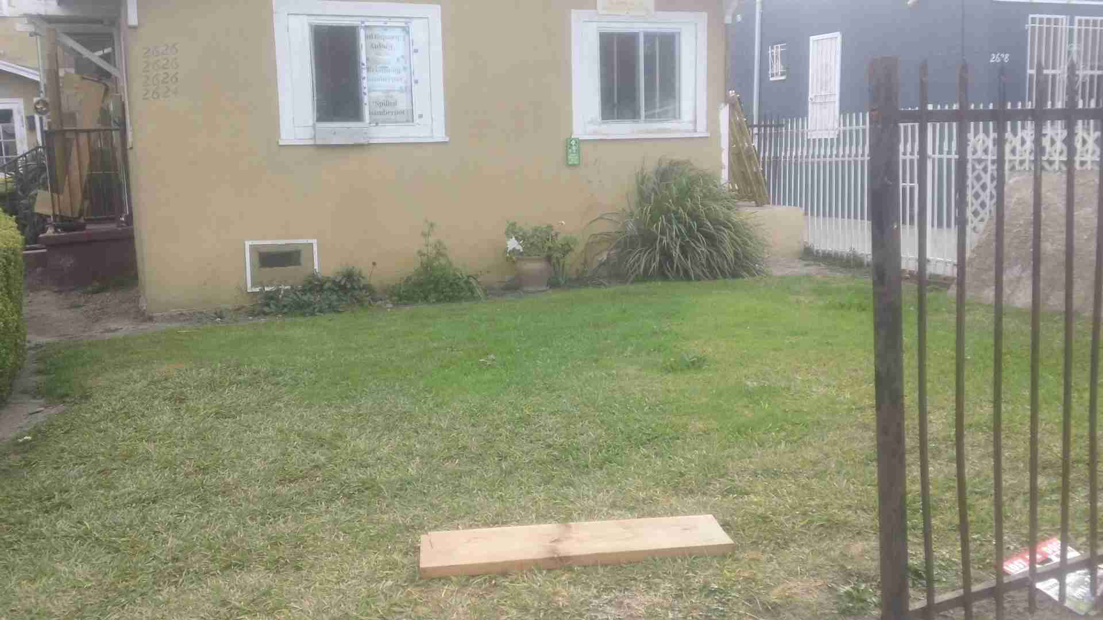Figure 6: The fourth item I'd put at curb, thrown back on the lawn, this also in December, 2024. There are no suspects at this time...
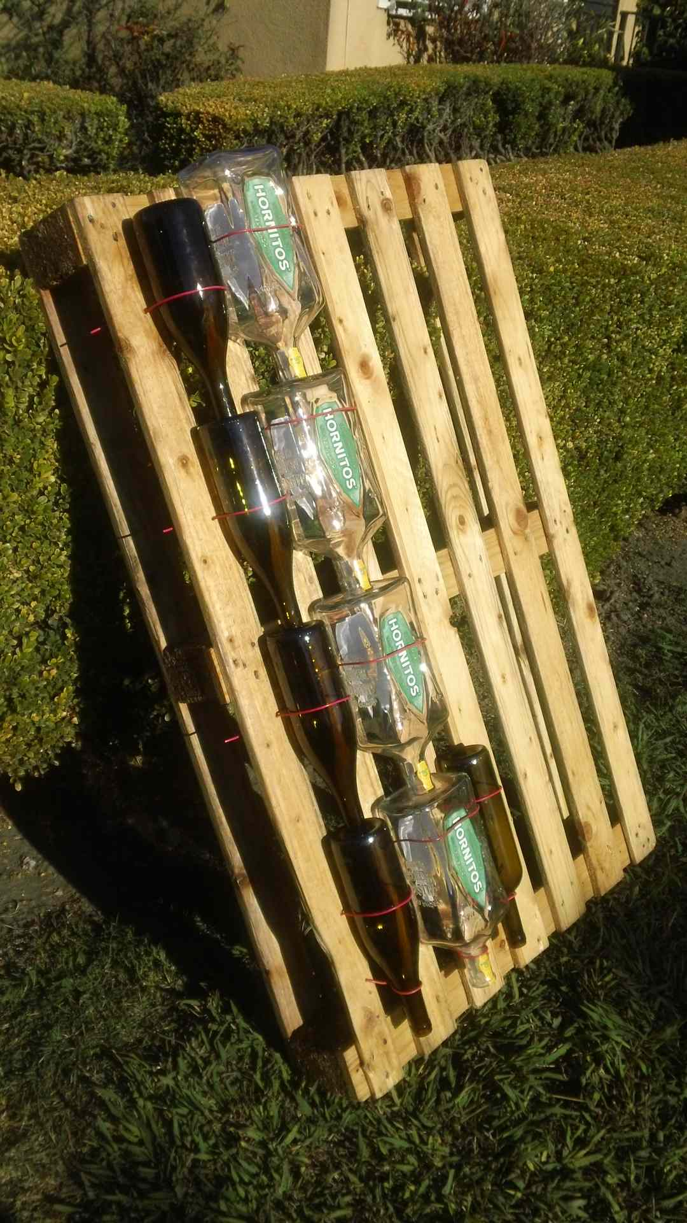Figure 7: My (vertical) Victory Garden partly populated with scavenged or donated glass bottle, ready for the vermicompost soil I hope to buy from Apricot Lane Farms in Moorpark.
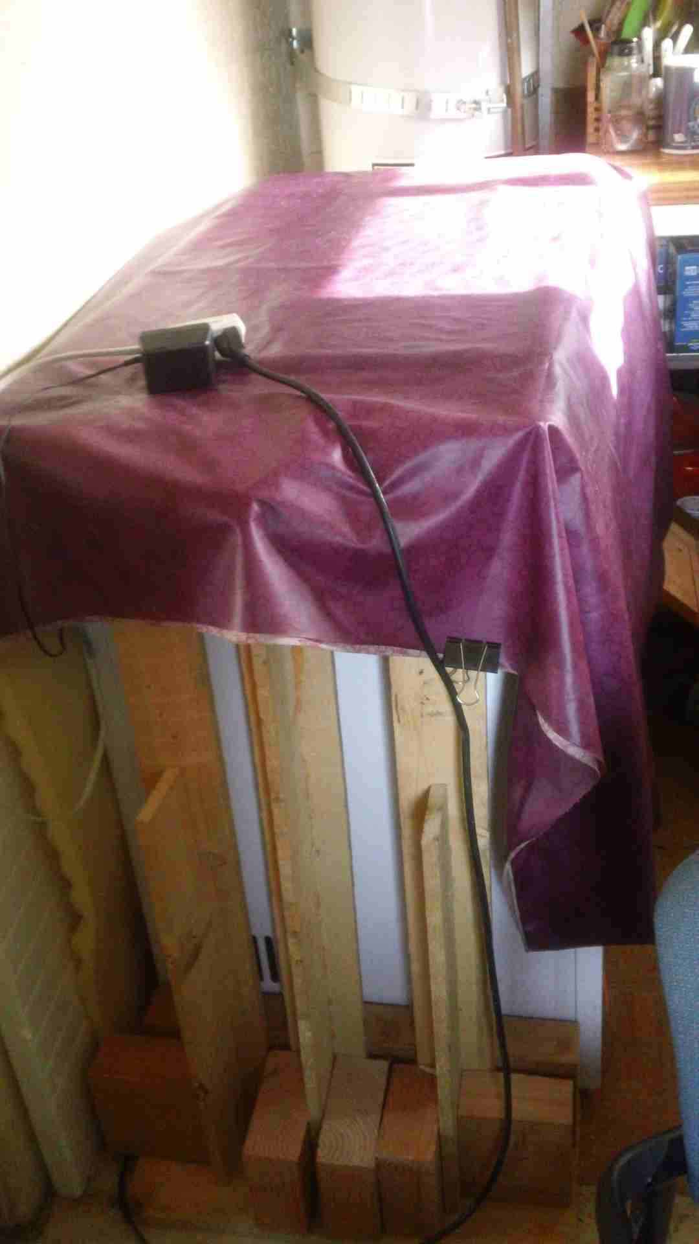Figure 8: The low power fridge/freezer pair. I think I can sell this arrangement to RV owners if I run it from a solar panel.
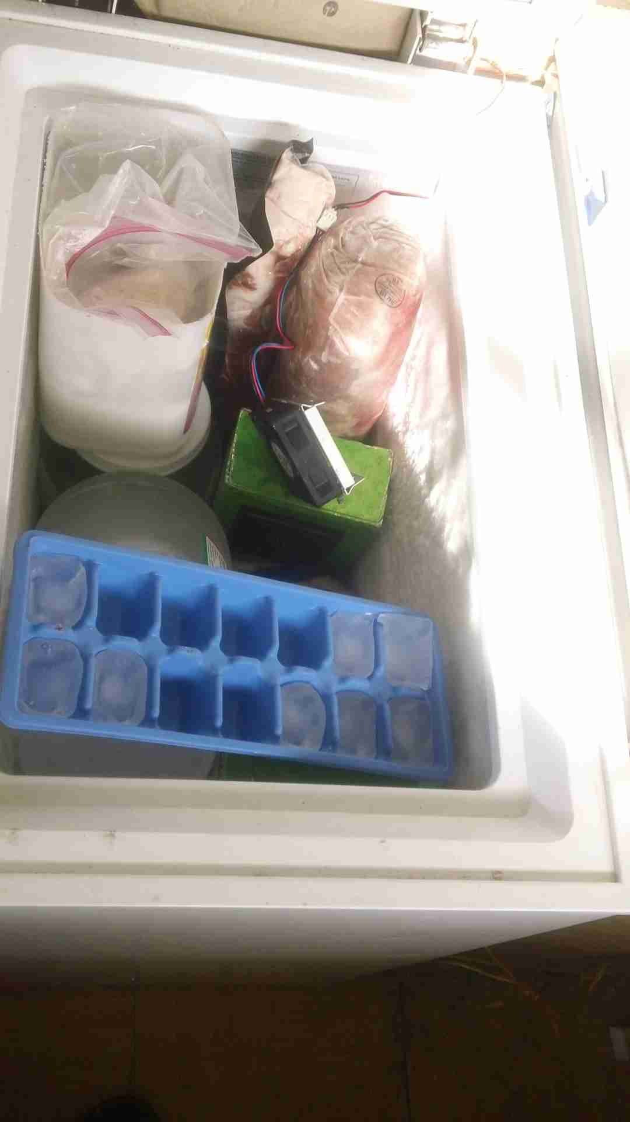Figure 9: Opened to of chest freezer, notice fan circulating inside air over gallon jug of ice.

(18) Beruf: Luftmensch (A new section in which I discuss progress. if any… on my projects):

(1) Made a folding tabletop for my fridge and freezer which combines convenience (doubles my countertop space) with insulation. I will implement a cold storage scheme to ensure they only need direct solar energy without need for batteries at night. (2) Assembled part of a vertical garden to be put on my south-facing wall, I hope to grow veggies there (3) Added a (removable) fan to dry out the crawl space under my bungalow, in the hope of controlling mold (4) A ground-mounted wheeled frame to hold a kilowatt of solar panels which will run my bungalow allowing me, at long last, to disconnect from DWP electricity.

(19) Les Lamentations d’un Batracien Désabusé:

I don’t believe Irene takes La Repubblica anymore <insert demented cackle>. For them as wish to decipher this, see Udo Ulfkotte’s Gekaufte Journalisten.

A paradox: the fear that, should I not continue to behave I might turn out to be far worse than those around me helps keep me on the straight and narrow.

Q: Folks, just how many more books do I have to write? Eh? A: Faut bien savoir montrer patte blanche!

I watch what news as will put a smile on me face: NNN, the Nikolai Nikolaievich Network, i.e., YouTube’s Nicolai Lilin. When I want facts, I listen instead to local radio made flesh: Saint Bernard™, for he has the straight dope.

If I’m guilty of contempt and of looking at y’all as idjits, don’t give it a second thought; think a moment. You’ve only had a passing look at my facts whereas having lived this for fifty years; I’m still incredulous. A-and, I’m that Black who, here half a century, still doesn’t quite get it <insert demented cackle>.

(12-2-24) Still reeling from viewing a long-ago segment on the Oprah Show in which Vinnie Tortorich is bamboozled (his own word) into pretending he’s something he’s not. In addition to not exactly inspiring confidence in this here media I, above all, wonder whether, confronted with a lie, the tacit acceptance of which would further my prospects, would have the moral courage to quietly explain myself before immediately walking offstage. I. Wonder. I worry more about this than about the, the, the bother of facing “automata inconvenienced by a soul” every day. A regular little Savonarola, I am.

(12-6-24) Heard a YouTube segment last night in which Noam Chomsky referred to Russia’s invasion of the Ukraine as a crime. This feels … incomplete. As incomplete as when, during an hour-long interview, Antony Beevor, discussing the same war, did not once mentioning NATO. I dunno. Chomsky also spoke of something called the Fermi paradox. (Excessive) specificity? All in all, a puzzling talk leaving me sorely confused. Mebbe I’ll lay off the sauce for a while.

If I’m not delusional, what the Establishment may see in me is a potential pocket quisling. A safe pair of hands who, should it come to that, can be counted on to pour oil over troubled waters Negroes. In short, abomonation [sic: I’d not spelled it this way; printer’s devil, printer’s devil]. Under no circumstance will I speak for violence but quickly add: I have a story, I don’t have advice. I do wonder, though, about the various factions involved in our very own little mikhdal and, increasingly think: shades of gray.

I’ve made parallels between José Padilla and Yevgenia Ginzburg. Another, now. Based on his autobiography: Involuntary Journey to Siberia, between myself and Soviet dissident Andrei Amalrik:
- Exiled from Father/ exiled
- Unable attend father funeral/idem
- Wrote objectionable material/idem
- Refused a degree, forced to work odd jobs then charged w. “parasitism.” Me: carefully drive by a “hothouse atmosphere” with,. Had venets and natural progression of my personality taken course PENALIZED!
- Sentenced to exile forced labor, made his way to Moscow where he was able to get lawyer, appealed case, judgment overturned, on return to Moscow able to have his right of residence restored along with apartment/rooms./I’m envious.

When once, in conversation with Irene, I exulted: “It’s morning in America,” I neglected to add that the birds were a-chirping.

In an interview on YouTube channel High Performance, an interviewee offered the opinion: “Government isn’t very good at doing anything.” Well, I can attest to the fact that this particular government, at least, is pretty good at one thing, oppressing. True, the quality (of the bureaucracy) may not be there but then, quantity has a quality all its own.

(20) Malice: Personal or Government? (A Section in which, dredging up long-ago grievances in the manner of Father, I at least ask: Who?).
This has the benefits of allowing me to judge the quality of the atmosphere around me and you, Gentle Reader™ to judge the quality of the atmosphere within me (that is, my mental health):

- At Yale, walked off sidewalk in 1973
- At Caltech, ther commnent: “175er”

(21) Conclusions or (In the Immortal Words of Soul Brother #1 former president Obama) “The View from the Cheap Seats”:

Coming after me, as they did and have a pattern of doing, may be racism. But, when the US Government targets a Colette Walczak, munchkin straight outta deepest, darkest Indiana, and turns her into a globetrotting fiend (same as with my other sister, Irene), that is institutional insanity. Racism threatens some, institutional insanity threatens all. Am I justified here in bringing up Yehezkel Dror’s phrase “crazy states?”

Four bits of advice I’ve taken to heart: (1) Ignore it! (from a cop) (2) OK to be radical but not extremist! (from that Vladimir Vladimirovich. Advice meant for Blacks?) (3) Turn the other cheek! (from the Bible via Los Angeles Bishop Barron) (4) Calma te (pour colmater?), mulata! (from an unknown employee at the Superior Market)

I may be held for a fool, which I readily admit to being, when I openly confess to financial and other crimes, some without statutes of limitations, even going so far as to publish specifics. Yet I’m merely carrying out a promise of putting the facts of my own life and that of Father in the public domain. In. Their. Entirety. Gentle Reader™, I’m aware of broader, more general implications in this; are you?

Regarding the ICC indictments of some Israeli leaders, I think: a State solution can be a two-edged sword. On the one hand, I’ve heard Israel-Palestine actually counts and, presumably, meters the calories going into Gaza; itself not a pretty thought, Eh? But at least Jews have, if only theoretically, somewhere to turn to. On the other hand, consider the predicament of Blacks here; essentially stateless persons by virtue of being systematically victimized by the US Government. The word slave has its roots in the word Slav. People who, for the longest time, were bereft of properly functioning states which could offer some measure of protection. You pays yr money and you makes yr choice. And so I ask, are they still offering Nansen passports?

But, before you mourn the passing of the notion of the Arab nation, think. Think of the thriving slave markets of what is left of Libya, brought to you by the concerted efforts of France and The Dread Basilisk™, by which I mean Mrs. Hillary “We came, we saw, he died” Clinton. Old habits die hard, Eh?

I’ve said this place is plagued by several system failures. Specifically, improperly functioning or wholly non-existent feedback loops. If you have the right info, you ???? need feedback, if you don’t – as with the Inuit, a people without knowledge of biochemistry who, however, did have properly functioning feedback loops. Thus, over the course of millennia, were able to accumulated an exquisite appreciation of the choices to be made to guarantee lifelong health considering their very restricted food choices. Look at the body of a hunter-gatherer, with a beauty akin to that of a Greek statue. By comparison, ours don’t fare so well; think of the signs of kwashiorkor (beer belly?) evident in most of us. And so we, with plenty of biochemical knowledge but little in the way of properly working feedback mechanisms, are in dire straights; see the latest diet recommendations by the FDA, USDA, etc.

I don’t want anything except continued protection for myself and my one remaining sister. Nothing. I want to die poor, I want to die alone, a near-pauper. For me, the safest outcome.

(22) Quotations from Chairman Miaou (Those of you with either a long memory or a guilty conscience will get the reference):

Nowadays, for a diabetic to consult a run-of-the-mill MD is like a peasant going to the doctor or, God forbid, a dentist, during the Middle Ages.

(11-9-24) Have just heard the election results, half a loaf trumps no loaf at all, wot? A-and, anyway, anyone but “Kali” (Yuga?), I say. Why? As a card-carrying diabetic, I can only applaud the announced volte-face regarding the war in Ukraine. A non sequitur, you say? Nope! With some of his initiatives, Mr. Trump is addressing what I think are two big immediate threats to my health: bad food/medical care and an equally unhealthy stance toward a nuclear-armed country.

I’ve made a connection between Katyn and what happened to my family; these jokers are always made uneasy by the thought of competition, aren’t they? Difference being, the Soviet sewer (¿Falta plata?) was never air conditioned.

I used to ignore people out of a lack of interest, I now do so as a matter of doctrine.

The more powerful the State, the more it can afford gentleness/subtlety and Upaya (the Skillful Means) in dealing with its opponents; for it has the time.

I wonder what Mossadeq’s attitude toward the Jews of his country was.

My understanding of Mongol culture does not extend much beyond this: that, for them, odds of ten to one constituted a fair fight. I, in my daily struggle wiv’ Le Malin™, neglecting my, ummm, “logistics tail,” nowadays feel much the same <insert demented cackle>.

A convenient shorthand for civilization: “The Pyramid.” A term encapsulating the capacity to generate, the need for, and the heartlessness to exploit, differences and stratification. See Ismail Kadare’s book of the same title and, for those of you who indulge, the idea of Hive Cities, a setting (though a bit overdrawn for my purposes) of the video game Warhammer 40,000. Think Planet Kaputt™.

The more, the merrier.

“Nobody listens to scientists” (Credit James Cameron). I venture that nobody listens to paranoid schizophrenics either; just a guess...

David Epstein, the owner of Sound Solution, once said within earshot: ‘I want to know everything.” To whoever put him up to this, I’m sure it was not his idea: “I want you, Gentle Reader™, to know everything (about me and Father).”

My last word in this latest kaleidoscope of nausea, horror and malarkey I call Dispatches from the Manchurian Candidate Factory #37:
To my “Bef” Wolfson who, long ago, said I should keep a diary.
Thankyou!Thankyou!Thankyou!

(signed)
Bergendahl/Berg (as in Nuremberg) “Pukka Wanker” Hawkins

P.S. To my beloved sisters, Irene (upon whose enemies, confusion) and Colette Walczak (dead of cancer in 2018) and two other unfortunates as well, Mari Berg and Elmira Izmailova: May our wordless tears, yours and mine, eventually prove invincible.

P.P.S. On. M’a. Fait. Du. Tort.

